2020 Application

for

Homeless Housing and Assistance Program (HHAP)

Applications Accepted Beginning October 9, 2020

Amended on April 20, 2022

Homeless Housing and Assistance Program

Application Package

Please Read the Request for Proposals

Before Completing the Application

Due Date: This RFP is an open RFP, meaning proposals will be accepted for consideration on a continuous basis until funds are no longer available for award or until HHAC terminates or suspends the open-ended RFP. Please note, however that applications will not be accepted prior to October 9, 2020. When available funds are committed and/ or HHAC decides to terminate or suspend the acceptance of applications, a notice will be posted on the Office of Temporary and Disability Assistance (OTDA) website (www.otda.ny.gov). Applicants are urged to check the website prior to completing and submitting an application to determine whether proposals are currently being accepted. The RFP and Application may be downloaded from OTDA’s website.

Proposals Should Be Delivered to:

Homeless Housing and Assistance Corporation
c/o Bureau of Contract Management
NYS Office of Temporary and Disability Assistance
40 North Pearl Street, 12-D
Albany, New York 12243
(518) 486-6352
Attention: Marcos Ortiz

Number of Copies Required: One (1) original, two (2) hard copies, and five (5) complete electronic copies (on separate USB Flash/thumb drives) must be submitted.

Please note that the above contact and telephone number is for delivery purposes only.

Questions Regarding the RFP Should Be Directed to:

Homeless Housing and Assistance Corporation
Dana Greenberg
NYS Office of Temporary and Disability Assistance
40 North Pearl Street, 10-C
Albany, New York 12243
E-mail: dana.greenberg@otda.ny.gov

Questions regarding this RFP will be accepted continuously. No telephone inquiries will be accepted. Answers to all questions will be posted on OTDA’s website on an ongoing basis. Questions may be submitted via mail, fax or email. All questions must be typed.

Note on the Format of the Application

Hard Copy Applications
The hard copy applications and all supporting documents, with the exception of architectural plans, should be on 8 ½ x 11 letter-size paper. At least one complete set of full-size architectural plans is required, and copies of the plans reduced to letter size must be included in each hard copy of the application. Electronic copies of the applications should include scanned images of architectural plans (e.g. .pdf format).

Applications should be submitted in three-ring binders.

The Application is divided into five Exhibits. Each Exhibit should be separated by tabs (i.e., A-1, A-2, A-3, B-1, B-2, B-3, etc.). Supporting documents should be inserted after the HHAP Exhibit to which they relate. Documents relating to the Support Services Plan, for instance, should follow the page labeled “Exhibit C-4 Support Services Plan.” Please limit attachments to only relevant information that is directly responsive to the RFP. Excessive or ancillary supplementary information may not be reviewed and may adversely affect the application.

Bound audited financial statements can be inserted into the sleeve of the front cover of an application binder. Be sure to note in Exhibit D-3 where the audit can be found.

When the space provided in the Application is not adequate for a response to a question, attach an additional page and label it clearly as a continuation of the response to the question.

When the pages of supporting documents and continuation pages of an Exhibit have been inserted, the Exhibit should be numbered sequentially. For instance, Exhibit A pages 1-15, Exhibit B pages 1-20, Exhibit C pages 1-23, etc. Page numbers should then be transferred to the “Checklist of Required Information and Documentation.”

Page numbers, along with the name of the applicant or an abbreviation for the name, should be in the lower right-hand corner of each page.

To the extent possible, architectural plans should be bound within the submission package. Plans that are not bound must be clearly marked with the applicant’s name, the project name, the site address and date submitted.

Please do not submit the request for proposals itself or the definitions section of the HHAP application.

Electronic Copies
Note that electronic copies must be submitted on one or more thumb drives. Acceptable file types include Word (.doc, .docx), Excel (.xls, .xlsx), Adobe (.pdf), Joint Photographic Experts Group (.jpg), and Graphics Interchange Format (.gif), as appropriate to the format of the application and the supplementary information required. A table of contents listing all electronic files and clearly identifying the section of the application to which they pertain must be included. File names must begin with a reference to the section of the application to which they pertain. The table of contents and attachments should mirror the hard copies of the application. For instance, “Exhibit C-4 Support Services Plan.” The electronic copies of the application should consist of a series of Exhibits and backup documentation. Electronic versions of the application that consist merely of a scanned version of the entire application will be deemed unresponsive to the RFP.

Note on the Completeness of the Application

All proposals received must be in the form and contain the content as set out in this Application. Applications which are deemed incomplete or otherwise fail to meet the requirements of the RFP may be disqualified from consideration.

Exhibit | New Units | Preserved Units | HHAP Operational
A-1 Project Summary | X | X | X
A-2 Applicant Information | X | X | X
A-3 Co-Applicant | If applicable | If applicable | If applicable
A-4 Building Information | X | X | X
A-5 Project Summary | X | X | X
A-6 Development Team | X | X | If applicable
A-7 Site Control | X | X | Deed & HHAC Contract #, and any existing mortgages
A-8 Community Relations | X | X | X
B-1 Development Budget | X | X | X
B-2 Explanation of the Development Budget | X | X | X
B-3 Description of Non-HHAP funds Required for Development | X | X | X
B-4 First Year Operating Budget | X | X | X
B-5 Notes to First Year Operating Budget | X | X | X
B-6 Projected Annual Expenses for 7 years | X | X | X
B-7 Explanation of Projected Expenses | X | X | X
B-8 Projected Revenue Stream and Cash Flow for Seven Years | X | Also include Question #3 | Also include Question #3
C-1 Documentation of Need
Community Description | X | X | N/A
Target Population | X | X | X
Gap Analysis | Section 3: New Units | Section 4: Preservation OR  Section 5: Combination - Preservation & New Units | Section 4: Preservation  OR  Section 5: Combination - Preservation & New Units. Section 6
C-2 Project Licensing/ Certification | If applicable | If applicable | If applicable
C-3 Program Description | X | X | X
C-4 Support Services Plan | X | X | X
C-5 Management and Operating Plan | X | X | Also include Question #7
D-1 Applicant Information and Financial Status
Description of Applicant Agency | X | X | X
Current Organization Chart | X | X | X
Resumes of Key Staff | X | X | X
Board of Directors Profile/ Narrative of Relevant Experiences | X | X | X
Agency Development Experience | X | X | N/A
Agency Funding History | X | X | X
Certificate of Good Standing | X | X | X
Certificate of Incorporation and all Amendments | X | X | X
By-Laws and all Amendments | X | X | X
IRS 501(c) (3) Ruling | X | X | X
Sectarian Organization Compliance Checklist | X | X | X
Current Audited Financial Statement | X | X | X
Most Recent Uniform Guidance Audit for Federally funded programs | If applicable | If applicable | If applicable
Management Letter | If applicable | If applicable | If applicable
Narrative Explanation of Financial Position | X | X | X
LLC Articles of Organization | For projects including Low-Income Housing Tax Credits | For projects including Low-Income Housing Tax Credits | For projects including Low-Income Housing Tax Credits
LP Partnership Agreement | For projects including Low-Income Housing Tax Credits | For projects including Low-Income Housing Tax Credits | For projects including Low-Income Housing Tax Credits
Co-Applicant Membership Agreement and List of Members/ Directors | For projects including Low-Income Housing Tax Credits | For projects including Low-Income Housing Tax Credits | For projects including Low-Income Housing Tax Credits
D-2 M/WBE and EEO Participation and Service-Disabled Veteran-Owned Business Enterprises | X | X | X
D-3 Required Certifications | X | X | X
E-1 Site Description | X | X | X
E-2 Site Development Information | X | X | X
E-3 Scope of Work and Cost Estimate | X | X | Also include Question #7. Include Question #8, if applicable
E-4 Energy Efficiency | X | As applicable | As applicable
E-5 Zoning and Status of Local Approvals | X | X | X
E-6 Project Timeline | X | X | X
E-7 SHPO/SEQRA | X | X | X
E-8 Flood Plain Letter | X | X | X
E-9 Site Photos | X | X | Also include Question #2
E-10 Floor Plans | X | X | X

Definitions

Commitment Letter - A letter of commitment documents that a specific resource will be made available to the project such as in-kind services, other development funding, operating funding and donations. Commitment letters should be project specific, clearly delineate the resources to be made available and identify any terms and conditions.

Congregate Project - A congregate project is one in which residents are not provided with a self-contained dwelling unit (i.e., living, sleeping, kitchen and bath facilities). In congregate projects, tenants are provided with private or shared sleeping accommodations with shared common areas that may include kitchens, living rooms and bathrooms. In congregate projects, each sleeping room (regardless of the number of individuals it will accommodate) should be reported as one congregate unit. For instance, an emergency domestic violence facility located within a four-bedroom single family house that is able to accommodate nine beds would be characterized as four congregate units, with nine beds.

Construction Financing – Short-term funds used to cover the cost of construction of a project before obtaining long-term or permanent financing.

Construction Management/Manager - Special management services provided to a sponsor by an individual or firm with the requisite experience during the design and/or construction phases of a project. Such services may include advice on the time and cost consequences of design and construction decisions, scheduling, cost control, coordination of contract negotiations and awards, timely purchasing of critical materials and long-lead items, and coordination of construction activities.

Equipment - All major appliances and systems should be included in the construction budget (Development Budget Summary line C.1). Equipment includes individual and/or central kitchen appliances, washers/dryers and security systems.

Existing Homeless Housing Unit - An existing homeless housing unit is one that is under contract to house the homeless. Additionally, if an agency’s corporate purpose is limited to providing services to the homeless, any units managed are considered existing units.

Furnishings - All furnishing costs (including apartment, office and common areas) should be listed as “Furniture” under “Other than Project Costs” (Development Budget Summary line G.1). Those applicants not requesting funds for furniture must provide evidence of an adequate furniture allowance from other sources.

General Contractor - The prime contractor responsible for most of the construction work, including work performed by subcontractors.

HHAP Operating Project - An existing housing project that is under contract with HHAC to house homeless persons.

Homeless - A homeless person is defined as an undomiciled person (whether alone or as a member of a family) who is unable to secure permanent and stable housing without special assistance, as determined by the Commissioner of OTDA.

Letter of Support - A letter of support indicates that the representative or entity is in favor of the proposed project. Be sure that each letter accurately describes the project. All letters of support must be dated within six (6) months of the submission date of this application. Letters of support do not substitute for commitment letters or linkage agreements.

Life-Cycle Cost - The total cost of acquisition, installation, operation, and maintenance of a building component (e.g. system, fixture, appliance, etc.), over and in relation to its useful life.

Linkage Agreement - A linkage agreement documents working relationships with other organizations. Linkage agreements should include: the names of the agencies signing, specific details about the activities occurring under the agreement, which services/resources each party to the agreement has committed to provide, a timeline for the agreement, executive signatures and date signed. Linkage agreements are also known as Memorandums of Understanding (MOU) or Memorandums of Agreement (MOA).

Long-form Certificate of Good Standing - A document issued by the NYS Department of State that certifies the not-for-profit organization is in existence, in good standing and lists all amendments to the original Certificate of Incorporation that have been filed. This document should also be provided for any other entity involved in the project, such as LLCs and Limited Partnerships.

Moderate Rehabilitation - A project in which the per unit total development cost is no more than $25,000.

Operating Reserve - An operating reserve is a set aside of funds to cover unforeseen cash flow problems which may arise in a project, such as an unusually high vacancy rate and/or uncollectable rate.

Other than Project Costs - Other than Project Costs include costs not directly associated with the development of the physical plant. These costs include Start-Up Costs and reserves. Funding for Other than Project Costs is limited, in the aggregate, to 25% of the HHAP annual appropriation.

Permanent Financing – Long-term funding, usually used to repay a construction loan.

Repairs and Maintenance - The amount of money set aside for painting, cleaning and general repair work that is necessary to keep the property and equipment in effective operating condition.

Replacement Reserve - A replacement reserve is a set aside of funds earmarked to replace certain building components at the conclusion of their useful life.

Scattered site - A scattered site project is one with multiple sites, post construction, that are not contiguous and separated by different Section, Block and Lot numbers.

SPOA – Single Point of Access: A centralized intake process for referrals for high-intensity mental health services.

Start-Up Costs - These are non-recurring costs associated with the start-up of the project including personnel costs and initial operating expenses. Funding for such expenses is limited to no more than 25% of the first-year operating budget.

SHARS - The Statewide Housing Activity Reporting System (SHARS) is maintained by NY Homes and Community Renewal (HCR). SHARS is an automated system for tracking, reporting and monitoring certain housing projects that apply for and/or receive state funds. If a property included in this application has applied for or previously received an investment of state funds, please contact HCR to determine if a SHARS ID number already exists.

Subcontractor - A person or firm who has a direct contract with the general contractor to perform a portion of the construction work. Examples include electrical, plumbing, painting, HVAC, etc.

Substantial Rehabilitation - A project in which the per unit total development cost exceeds $25,000.

Total Development Cost - The sum of all costs directly related to the development of the physical plant including: construction, acquisition-related costs (but not the cost of the building/land), professional service fees and other development costs.

Total Project Cost -The sum of Total Development Cost, Acquisition and Total Other than Project Costs.

Unit - A Unit is a self-contained subdivision within a project. Such subdivision can include: a one-family apartment, a private sleeping room in a single room occupancy (SRO) residence, a single bedroom in a congregate facility, or each subdivision in a dormitory type setting. Any of these can include access to common areas in the building. Such common areas are not counted as units.

Checklist of Required Information and Documentation
This checklist should be completed after the rest of the application. The page numbers should reflect those which have been added on the lower right-hand corner of each page.
(Page 1 of 3)
IMPORTANT NOTE: If “Not Applicable” is checked for any item, provide an explanation following the appropriate Exhibit as to why the information is not included.
 | Exhibit | Check if  Provided | Page  Number(s) | Check if  Not  Applicable
A-1 | Project Summary Information
A-2 | Applicant Information
A-3 | Co-Applicant/Supporting Organization Information
A-4 | Building Information
A-5 | Project Summary Narrative
A-6 | Development and Management Team
A-7 | Site Control
 | Evidence of Site Control
A-8 | Local Social Services District Approval/Community Relations
 | Community Relations Narrative
 | Evidence of Notification to Local Planning Authority
 | Evidence of LDSS Notification
 | Evidence of Support by Local Continuum of Care
 | Letters of Community Support
B-1 | Development Budget Summary
B-2 | Explanation of Development Budget Items
B-3 | Description of Non-HHAP Funds Required for Development
 | Evidence of Commitment of Non-HHAP Funds
 | Mortgage/Partnership/Loan Agreements
B-4 | First Year Operating Budget
B-5 | Notes to First Year Operating Budget
 | Evidence of Revenue Commitment(s)
B-6 | Projected Annual Expenses for Seven Years
B-7 | Explanation of Projected Expenses
 | Documentation of Major Expense Categories
B-8  C-1  C-2 | Projected Revenue Stream and Cash Flow for Seven Years  Documentation of Need  Project Licensing/Certification
Checklist of Required Information and Documentation
(Page 2 Of 3)
 | Exhibit | Check if  Provided | Page  Number(s) | Check if  Not  Applicable
C-2 | Evidence of Application to/ Commitment from Regulatory Agency
C-3 | Program Description
 | Documentation of Referral Sources
C-4 | Support Services Plan
 | Linkage Agreements
C-5 | Management and Operating Plan
D-1 | Description of Applicant Agency
 | Current Organization Chart
 | Resumes of Key Staff
 | Board of Directors Profile/Narrative of Relevant Experience
 | Agency Development Experience
 | Agency Funding History
 | Certificate of Good Standing (long form)
 | Certificate of Incorporation and all Amendments
 | By-Laws and all Amendments
 | IRS 501(c)(3) Ruling (HDFC’s are NFP, but not 501c3)
 | Sectarian Organization Compliance Checklist
 | Current Audited Financial Statement (less than one-year old)
 | Most Recent Uniform Guidance Audit for Federally funded programs (less than one-year old)
 | Management Letter (if applicable)
 | Narrative Explanation of Financial Position
 | LLC Articles of Organization
 | LP Partnership Agreement
 | Co-Applicant Membership Agreement & List of Members/ Directors
 | List of Affiliates
 | Affiliate Financial Statements
 | Appendix B: Architect’s Certification

Checklist of Required Information and Documentation
(Page 3 of 3)
 | Exhibit | Check if  Provided | Page  Number(s) | Check if  Not  Applicable
D-2 | OTDA-4070 MWBE EEO Statement
 | OTDA-4934 Staffing Plan
 | OTDA-4937 MWBE Utilization Plan
 | OTDA-4976 MWBE Certification of Good Faith Efforts
 | SDVOB-100 Utilization Plan
 | SDVOB-200 Waiver Request
D-3 | Vendor Responsibility Questionnaire
 | Non-Discrimination in Employment in Northern Ireland
 | Non-Collusive Bidding Certification
 | Agreement
 | Vendor Assurance of No Conflict of Interest or Detrimental Effect
E-1 | Site Description
E-2 | Site Development Information
 | Existing Certificate of Occupancy
E-3 | Scope of Work and Cost Estimate
 | Outline Specifications
E-4 | Energy Efficiency
E-5 | Zoning Analysis and Status of Local Approvals
E-6 | Project Timeline
E-7 | SHPO/SEQRA
 | Short Environmental Assessment Form
E-8 | Flood Plain Letter
E-9 | Site Photographs
E-10 | Existing Floor Plans
 | Proposed Floor Plans*
*One complete set of full-size architectural plans must be submitted, and copies of the plans reduced to 8 ½” x 11” must also be included in each copy of the application.
Exhibit A-1: Project Summary Information
(Page 1 of 3)

Applicant:
Project Name:
County:
(for the proposed project site)

Housing Type (Check all that apply): Permanent Transitional Emergency
Project Population (Check all that apply): Families (units ) Singles (units )
Families & Singles

HHAP Population (Check all that apply): Families (units ) Singles (units )
Families & Singles

Total Project Units: Total HHAP Units:
Total Project Beds*: Total HHAP Beds*:
Number of New Units: Number of Preserved Units:
Preservation of an Operating HHAP Project: Yes No
Is this a Scattered Site Project: Yes No
Number of Buildings: Gross Square Footage:
Development Budget Summary
Source | Amount
1. HHAP Funds Requested | $
2. | $
3. | $
4. | $
5. | $
6. | $
Total Funds From All Sources | $0.00

Construction Cost** |  |  | Total Project Cost***
Total | $ |  | Total | $
Per Unit | $ |  | Per Unit | $
Per Bed | $ |  | Per Bed | $
Per Square Foot | $
*Please use the following guidelines to estimate the number of beds per unit:
Studio = 1 bed per unit
1 bd = 2 beds per unit (if housing for singles, 1 bed per unit)
2 bd = 3 beds per unit
3 bd = 5 beds per unit
4bd =6 beds per unit
** Line C1 from the Development Budget Summary
*** Line H from the Development Budget Summary

EXHIBIT A-1: Project Summary Information
(Page 2 of 3)

Commitment of Development Funding Sources
Identify below the other sources of development funding by agency, program, the status of commitment, and date of application, if not committed: (check all that apply)

Agency Program(s) Committed Date of Application
New York Homes ___________________ ______________
and Community Renewal (HCR)

Housing Finance Agency (HFA) ___________________ ______________

Office of Mental Health (OMH) _ ___________________ ______________

NYC Department of Housing ____________________ ______________
Preservation and Development (HPD)

NYC Housing Development ____________________ ______________
Corporation (HDC)

Other: ___________________ ____________________ ______________

___________________ ____________________ ______________

EXHIBIT A-1: Project Summary Information
(Page 3 of 3)
Special Populations (Specify only if the program will be specifically tailored, in all respects, to a special needs population; if there are no special populations, leave this section blank):
Physically Disabled Total Units: HHAP Units: ESSHI Units/ Beds: /_____
Re-entry/ Ex-Offenders Total Units: HHAP Units: ESSHI Units/ Beds: /_____
Severe Mentally Ill Total Units: HHAP Units: ESSHI Units/ Beds: /_____
Pregnant/Parenting Teens Total Units: HHAP Units: ESSHI Units/ Beds: /_____
Substance Use Disorder Total Units: HHAP Units: ESSHI Units/ Beds: /_____
Veterans Total Units: HHAP Units: ESSHI Units/ Beds: /_____
Victims of Domestic Violence Total Units: HHAP Units: ESSHI Units/ Beds: /_____
Youth/Runaway Total Units: HHAP Units: ESSHI Units/ Beds: /_____
Elderly Total Units: HHAP Units: ESSHI Units/ Beds: /_____
Youth Aging Out of Foster Care Total Units: HHAP Units: ESSHI Units/ Beds: /_____
Persons with HIV/AIDS Total Units: HHAP Units: ESSHI Units/ Beds: /_____
Developmentally Disabled Total Units: HHAP Units: ESSHI Units/ Beds: /_____
Chronically homeless Total Units: HHAP Units: ESSHI Units/ Beds: /_____
Other: Total Units: HHAP Units: ESSHI Units/ Beds: /_____

Is the project seeking or has it obtained an award of service & operating funding under the Empire State Supportive Housing Initiative (ESSHI)? Yes No

If the HHAP applicant is not the ESSHI awardee, please identify the ESSHI awardee and year of award: *Please provide ESSHI population referral information in Exhibit C-3

If the project will house one or more of the Special Populations listed above, it may be necessary for the project to demonstrate compliance with the Olmstead decision (Please see Section II. L of the RFP).

If the proposed project will house one or more of the Special Populations above, please complete the following:
1) Whether the Special Population triggers Olmstead compliance concerns and why; and
2) If Olmstead compliance is required, explain how the proposed housing project will be an integrated setting that enables individuals with disabilities to live independently. Please provide any determination from a State regulatory agency, as applicable.

Will the project be certified, licensed or otherwise regulated? Yes No
If yes, facility type: Regulatory/certifying agency:
EXHIBIT A-2: Applicant Information

Incorporated Name:
Contact Name: Mr. Ms. Executive Director: Mr. Ms.
Title: Title:
E-Mail: E-Mail:
Mailing Address:
County:
Phone:
Legal Status: | Non-Profit |  | Municipality | Public Corporation
 | Partnership |  | Local District | Other:
Charities Registration Number:
Federal Tax ID#: |  |  | Federal Tax-Exempt Status Received?

Type (Check all that apply)
City/ Town/ Village Government | Native American Tribal Organization
County Government | Public Benefit Corporation
Public Housing Authority | Non-Profit Corporation
Housing Development Fund Corporation
Jointly-Owned Entity (describe, and identify the involved not-for profit):

Legislative/Congressional Districts (for Applicant’s offices)
NYS Assembly District #: | Representative:
NYS Senate District #: | Representative:
Congressional District #: | Representative:

SHARS Applicant ID (if applicable):

President, Board of Directors: Mr. Ms.
Mailing Address:

Phone: | E-Mail:
EXHIBIT A-3: Co-Applicant/
Supporting Organization Information

Applicant Type: Co-Applicant Supporting Organization
Incorporated Name:
Contact Name: Mr. Ms.
Title:
Mailing Address:
County:
Phone: |  |  |  | E-Mail:
Legal Status: | Non-Profit |  | Municipality |  | Public Corporation
 | Partnership |  | Local District |  | Other
Charities Registration Number:
Federal Tax ID#: |  |  | Federal Tax-Exempt Status Received?

Type (Check all that apply)
City/ Town/ Village Government | Native American Tribal Organization
County Government | Public Benefit Corporation
Public Housing Authority | Non-Profit Corporation
Housing Development Fund Corporation
Jointly-Owned Entity (describe, and identify the involved not-for profit):

Legislative/Congressional Districts (for Co-Applicant’s offices)
NYS Assembly District #: | Representative:
NYS Senate District #: | Representative:
Congressional District #: | Representative:

SHARS Applicant ID:

President, Board of Directors: Mr. Ms.
Mailing Address:

Phone: | E-Mail:
EXHIBIT A-4: Building Information (Page 1 of 2)

Project Building Number: of

Note: This section is used by HHAP to collect basic information about each building. This section should be completed AFTER the rest of the application has been prepared. If more than one building is proposed for the project, duplicate and complete this page for each site (building) in the proposal and provide a summary page presenting cumulative information for all sites.

Total Building Units: HHAP Units:
Total New Units: HHAP New Units:
Total Preserved Units: HHAP Preserved Units:
Building Units and Beds by Housing Type

Total Emergency Units: HHAP Emergency Units:
Total Transitional Units: HHAP Transitional Units:
Total Permanent Units: HHAP Permanent Units:

Total Building Beds: HHAP Beds:
Total Emergency Beds: HHAP Emergency Beds:
Total Transitional Beds: HHAP Transitional Beds:
Total Permanent Beds: HHAP Permanent Beds:

Unit Breakdown

SRO Units: Total Units HHAP Units
Studio Units: Total Units HHAP Units
One-Bedroom Units: Total Units HHAP Units
Two-Bedroom Units: Total Units HHAP Units
Three-Bedroom Units: Total Units HHAP Units
Four-Bedroom Units: Total Units HHAP Units
Five-Bedroom Units: Total Units HHAP Units
Congregate Units: Total Units HHAP Units

Special Populations (from Exhibit A-1)

____________________ Total Units HHAP Units
____________________ Total Units HHAP Units
____________________ Total Units HHAP Units

Legislative/Congressional Districts (for proposed project site)
NYS Assembly District #: | Representative:
NYS Senate District #: | Representative:
Congressional District #: | Representative:
EXHIBIT A-4: Building Information (Page 2 of 2)

Project Building Number: of

Note: This section is used by HHAP to collect basic information about each building. This section should be completed AFTER the rest of the application has been completed. If more than one building is proposed for the project, duplicate and complete this page for each site (building) in the proposal.

SHARS Building ID# (if applicable):
Prior Funding SHARS ID# (if applicable):
Street:
Number Name
Municipality:
Zip:
Municipality Type: City County Town Village
County:
Parcel Section #: Block #: Lot #:
Easement #: Census Tract #:
Current Owner:
Current Use: Vacant Land Residential Structure
Mixed Use Commercial/Industrial
Building Gross Square Footage:

Activity Proposed (Check all that apply):
Acquisition Moderate Rehabilitation
Substantial Rehabilitation New Construction

Tenure Type Proposed:
Single Family Condominium Rental Cooperative

Can this site be developed “as of right”? Yes No

If No, identify contingencies:
Code Variance Special Use Permit Use Variance Other:
Area Variance Easement Site Plan Review
EXHIBIT A-5: Project Summary Narrative

Provide a complete narrative summary of the proposal. The narrative should be presented in such a way so that someone who has not read the application will get a good sense of the proposed project. At a minimum, please include the following: sponsor; co-sponsor; HHAP request; total funding necessary to complete the project; sources and status of other funding; total number of units and beds; total number of HHAP units and beds; location; housing type; population; type of construction; and source of operating funds. Please be concise. There will be opportunity later in the application to provide greater detail.

Add additional sheets if needed and label Project Summary
EXHIBIT A-6: Development and Management Team (Page 1 of 2)
Provide contact information for all members of the proposed development and management team. Add additional sheets as necessary.

Consultant:
Firm:
Contact: Mr. Ms.
Mailing Address:
Phone: |  | E-Mail:

Architect:
Firm:
Contact: Mr. Ms.
Mailing Address:
Phone: |  | E-Mail:

Attorney:
Firm:
Contact: Mr. Ms.
Mailing Address:
Phone: |  | E-Mail:

Other (specify):
Firm:
Contact: Mr. Ms.
Mailing Address:
Phone: |  | E-Mail:

Other (specify):
Firm:
Contact: Mr. Ms.
Mailing Address:
Phone: |  | E-Mail:

EXHIBIT A-6: Development and Management Team
(Page 2 of 2)

A) Detail the respective roles and responsibilities of each entity necessary for the development, operation and provision of services at the proposed project. Please include a brief synopsis of the relevant experience of each entity, and identify any prior experience with HHAP, if applicable.

B) Identify below whether there is any direct or indirect financial or other interest that any member of the development or management team may have with any other member of the team (including the applicant or co-applicant) or the funding of this project. See Section III. A. 2 of the RFP.

C) Please refer to Appendix G of the RFP and identify below whether any potential conflict of interest exists.

D) Following this page, please briefly describe the qualifications of the proposed consultant, if any, and include a draft scope of work.

E) If the proposed project involves funding from Low Income Housing Tax Credits, please attach a proposed organization chart depicting the organizational and ownership structure, degree and nature of ownership interests, and roles of the entities to be involved in the project.

EXHIBIT A-7: Site Control
Prepare a separate page for each building/site (Page 1 of 3)

Site of

Site Address:
Street City Zip
Who currently owns this site?

Describe the relationship (if any) between the current owner and applicant (including board members, officers, staff, and/or their family members).

If the applicant currently owns the site, explain when it was acquired, the price and any special conditions under which it was acquired, and the uses of the site, if any, since acquired.

Explain any deed restrictions affecting the project site.

If requesting funding to “buy down” an existing mortgage, explain how the reduction in debt service will have a positive impact on the long-term finances of the project and/or directly benefit residents.

If the applicant does not own the site, briefly explain the process to acquire it if an HHAP funding commitment is received.

If the applicant has a purchase and sale, option to buy, or similar agreement/authorization relative to the site, please provide the expiration date, if any, and whether renewals are permitted. Also, please indicate below whether the expiration date is more than six months from submission of this application.

Does site control document expire within six months of the date of application submission?

Within six months More than six months

EXHIBIT A-7: Site Control
Prepare a separate page for each building/site (Page 2 of 2)

Check below the level of site control documentation available, and attach such documentation following this page (check all that apply).

For sites to be purchased or leased: For sites currently owned/leased:
Draft Deed Deed
Draft Lease Lease*
Contract for Sale
Option Agreement
Letter from Public Agency
Other (specify):

*For leaseholds, applicants must provide evidence that a lease for at least 25 years from the date of occupancy can be negotiated prior to contract execution. For sites to be purchased or currently owned, please provide an appraisal and most recent title update if available. (Please note, an independent appraisal by a qualified NYS certified appraiser may be required prior to closing.)

For Preservation of HHAP Operating Projects Only:

If requesting funds for the preservation of an HHAP Operating Project, please provide the following information below:

HHAC Contract Number:

Project ID number:

Describe any mortgages other than to HHAC and/or any deed restrictions on the project site.

EXHIBIT A-8: Local Social Services District Approval/ Community Relations

Following this page, please attach the items requested below:

On a separate page marked “Community Relations”, describe the relationship between the project development efforts (both to date and planned for the future) and the community in which the project would be located. Specifically, detail the relationship with Neighborhood or Block Associations, if any, and their position relative to this application.

Evidence that the local planning board (in NYC, Community Board) has been notified of the proposed project, and if no local planning board, its equivalent in the community the project is located.

Documentation that the Local Social Services District has at minimum been notified of the proposed project.

A statement from the local Continuum of Care supporting the proposed project.

Letters of community support. All letters of support must be dated within six (6) months of the submission date of this application. Letters of support do not substitute for commitment letters or linkage agreements (Please refer to the definition section of this application).

EXHIBIT B-1: Development Budget Summary
(Following this page detail Legal, Consultant, Furniture, Equipment and Start-Up Costs)
Address:
 |  | HHAP | Other Source 1 | Other Source 2 | TOTAL
A. | ACQUISITION
 | 1. Cost of Building/Land | $0 | $0 | $0 | $0
B. | ACQUISITION-RELATED COSTS
 | 1. Appraisal | $0 | $0 | $0 | $0
 | 2. Closing Fees | $0 | $0 | $0 | $0
 | 3. Title Insurance | $0 | $0 | $0 | $0
 | 4. Legal Fees (Related to Acquisition) | $0 | $0 | $0 | $0
 | 5. Other (e.g. buy-down of existing mortgage) | $0 | $0 | $0 | $0
 | 6. TOTAL LINES 1 -5 | $0 | $0 | $0 | $0
C. | CONSTRUCTION COSTS
 | 1. Construction/Rehabilitation | $0 | $0 | $0 | $0
 | 2. Contingency (5% new; 10% rehab) | $0 | $0 | $0 | $0
 | 3. Construction Manager Fee ( %) | $0 | $0 | $0 | $0
 | 4. TOTAL LINES 1 - 3 | $0 | $0 | $0 | $0
D. | PROFESSIONAL SERVICE FEES
 | 1. Architectural | $0 | $0 | $0 | $0
 | 2. Legal Fees (Unrelated to Acquisition) | $0 | $0 | $0 | $0
 | 3. Consultant* | $0 | $0 | $0 | $0
 | 4. Developer's Fee* | $0 | $0 | $0 | $0
 | 5. Other (define) | $0 | $0 | $0 | $0
 | 6. TOTAL LINES 1 - 5 | $0 | $0 | $0 | $0
E. | OTHER DEVELOPMENT COSTS
 | 1. Survey | $0 | $0 | $0 | $0
 | 2. Asbestos Test, Abatement, Monitoring | $0 | $0 | $0 | $0
 | 3. Owners Insurance for Construction | $0 | $0 | $0 | $0
 | 4. Tax Exemption Fees | $0 | $0 | $0 | $0
 | 5. Lead Test, Abatement, Monitoring | $0 | $0 | $0 | $0
 | 6. Other (define) | $0 | $0 | $0 | $0
 | 7. TOTAL LINES 1 - 6 | $0 | $0 | $0 | $0
F. | TOTAL DEVELOPMENT COST (B - E) | $0 | $0 | $0 | $0
G. | OTHER THAN PROJECT COSTS
 | 1. Furniture and Equipment | $0 | $0 | $0 | $0
 | 2. Start-up Costs | $0 | $0 | $0 | $0
 | 3. Replacement Reserve | $0 | $0 | $0 | $0
 | 4. Operating Reserve | $0 | $0 | $0 | $0
 | 5. TOTAL LINES 1 -4 | $0 | $0 | $0 | $0
H. | TOTAL PROJECT COST (A+F+G) | $0 | $0 | $0 | $0

*Refer to Maximum limits allowed by RFP
If more than one site, whether identified or not, this form MUST be completed for each site and a cumulative budget representing all sites must be presented. The Development Budget should reflect construction financing. Permanent sources and uses are described in Exhibit B-3.
EXHIBIT B-2: Explanation of Development
Budget Items

Please describe the basis for determining the cost of all items in the development budget (other than construction and acquisition). Specifically include how the amounts requested were determined for the following items, if applicable: hazardous materials testing, abatement, and monitoring; insurance; developer’s fees; furniture; equipment; start-up costs; and reserves. If the costs are based on quotes, please attach documentation of the quotes following this page. If based on agency experience with a similar project, identify and describe that project. Please provide the information for all line items, not just those to be funded by HHAP. If the reserves will be capitalized by another funding source, including tax credit equity and covered in the Development Budget under the developer’s fee line, please state how much of the developer’s fee will go to reserves.

EXHIBIT B-3: Description of Non-HHAP Funds
Required for Development (Page 1 of 2)

Please summarize below the status of commitment as well as the terms and conditions (i.e., interest rate, restrictions, timeline for availability, length of loan, etc.) of:

- Any mortgages currently secured by the project site (if the applicant already owns the property and/or will assume or buy down any existing mortgages).

- Any loans or major grants required for project development that have been applied for or already have committed to the project.

- Any private investment/partnership involved in project financing. If a partnership will be involved, include information, if available, on the identity and background of the general partner and actual or potential investors, structure of the syndication, and other relevant details of the proposed partnership.

- Attach copies of all letters of commitment/interest from other funding sources.

- If the project anticipates equity generated from the sale of low-income housing credits (LIHTC), provide the equity calculation and include the amount of the credit allocation, the anticipated raise and the total equity to be realized as a result of the allocation and raise. Please also include the anticipated LIHTC construction closing deadline date.

- Do any of the funding sources involved in the project trigger prevailing wage requirements?

No
Yes

- Please check the appropriate box if the documents listed below are applicable and available, and insert these documents after this page:

Existing mortgage (if the applicant owns the property)
Draft mortgage or loan documents
Draft partnership or operating agreement
Evidence of commitment of any other development funding source not included in items 2 and 3

EXHIBIT B-3: Description of Non-HHAP Funds
Required for Development (Page 2 of 2)

For projects with multiple funding sources, please list and differentiate between the sources of construction or permanent financing below:

CONSTRUCTION FINANCING
Source Amount
HHAP
Other:
Other:
Other:
Other:
Other:
Other:
Total Sources $

PERMANENT FINANCING
Source Amount
HHAP
Other:
Other:
Other:
Other:
Other:
Other:
Total Sources $

Please include any explanatory notes to the plan for construction financing and permanent conversion, if applicable:

Add additional sheets if necessary and label Non-HHAP Funding Continuation Sheet

EXHIBIT B-4: First Year Operating Budget

REVENUES
 | 1. HHAP Units – Initial Rents (Per month x 12 or per day x 365)
 | SRO Units | ( ) | @ |  | Per |  | = | $0
 | Studio Units | ( ) | @ |  | Per |  | = | $0
 | 1 Bedroom Units | ( ) | @ |  | Per |  | = | $0
 | 2 Bedroom Units | ( ) | @ |  | Per |  | = | $0
 | 3 Bedroom Units | ( ) | @ |  | Per |  | = | $0
 | 4 Bedroom Units | ( ) | @ |  | Per |  | = | $0
 | 5 Bedroom Units | ( ) | @ |  | Per |  | = | $0
 | Congregate Beds | ( ) | @ |  | Per |  | = | $0
 | Total HHAP Unit Rents |  |  |  |  |  |  | $0
 | Less Vacancy/Uncollectable (5%) |  |  |  |  |  |  | $0
 | Net HHAP Rents |  |  |  |  |  |  | $0
 | 2. Non-HHAP Units – Initial Rents (Per month x 12 or per day x 365)
 | SRO Units | ( ) | @ |  | Per |  | = | $0
 | Studio Units | ( ) | @ |  | Per |  | = | $0
 | 1 Bedroom Units | ( ) | @ |  | Per |  | = | $0
 | 2 Bedroom Units | ( ) | @ |  | Per |  | = | $0
 | 3 Bedroom Units | ( ) | @ |  | Per |  | = | $0
 | 4 Bedroom Units | ( ) | @ |  | Per |  | = | $0
 | 5 Bedroom Units | ( ) | @ |  | Per |  | = | $0
 | Congregate Beds | ( ) | @ |  | Per |  | = | $0
 | Total Non-HHAP Unit Rents |  |  |  |  |  |  | $0
 | Less Vacancy/Uncollectable (5%) |  |  |  |  |  |  | $0
 | Net Non-HHAP Rents |  |  |  |  |  |  | $0
 | 3. Commercial Units
 | Commercial Rent (0 sq. ft. @ 0.00/sq.ft.) |  |  |  |  |  |  | $0
 | Less Vacancy/Uncollectable (5%) |  |  |  |  |  |  | $0
 | Net Commercial Rents |  |  |  |  |  |  | $0
 | 4. Support Services/ Other Income (Specify)
 |  |  |  |  |  |  |  | $0
 |  |  |  |  |  |  |  | $0
 |  |  |  |  |  |  |  | $0
 | Total Other Income |  |  |  |  |  |  | $0
 | TOTAL REVENUES |  |  |  |  |  |  | $0

EXPENSES
1. | Building Maintenance and Operations
2. | Replacement and Operating Reserves
3. | Management Fee
4. | Maintenance Payroll
5. | Program Expenses
6. | Debt Service
 | TOTAL EXPENSES | $0

 | NET INCOME OR (LOSS) | $0

*Note: Revenue and expenses for support services should be reflected (not just for building). If support services will be provided in-kind or by another agency, this should be explained in detail and still included in the budget.
EXHIBIT B-5: Notes to First Year Operating Budget

REVENUES

- Describe the source of rents and/or subsidies for the HHAP units (e.g., ESSHI, Public Assistance Shelter Allowance, Section 8/Housing Choice Vouchers, negotiated reimbursement rates, etc.). Attach preliminary commitment letters for these revenues.

- Describe the source of non-HHAP residential rents (e.g. staff apartments, higher income tenants, etc.).

- Describe the type of tenants expected to occupy the commercial and/or non-residential space and provide evidence that the projected rent is sustainable for the area.

- Explain the source of “Support Service/ Other Income” listed and provide documentation of the availability of this income.

- Explain any vacancy/uncollectable rate that varies from the standard 5%.

Add additional sheets if necessary and label Notes to First Year Operating Budget Continued

EXHIBIT B-6: PROJECTED ANNUAL EXPENSES
FOR SEVEN YEARS
 |  |  | YEAR 1 | YEAR 2 | YEAR 3 | YEAR 4 | YEAR 5 | YEAR 6 | YEAR 7 | %Change
A. |  | OPERATING EXPENSES
 |  | 1. Real Estate Tax | $0 | $0 | $0 | $0 | $0 | $0 | $0 | 0.00%
 |  | 2. Water & Sewer Tax | $0 | $0 | $0 | $0 | $0 | $0 | $0 | 0.00%
 |  | 3. Fire/Liability/Other Insurance | $0 | $0 | $0 | $0 | $0 | $0 | $0 | 0.00%
 |  | 4. Fuel | $0 | $0 | $0 | $0 | $0 | $0 | $0 | 0.00%
 |  | 5. Utilities | $0 | $0 | $0 | $0 | $0 | $0 | $0 | 0.00%
 |  | 6. Exterminating | $0 | $0 | $0 | $0 | $0 | $0 | $0 | 0.00%
 |  | 7. Carting | $0 | $0 | $0 | $0 | $0 | $0 | $0 | 0.00%
 |  | 8. Repairs and Maintenance | $0 | $0 | $0 | $0 | $0 | $0 | $0 | 0.00%
 |  | 9. Legal and Accounting | $0 | $0 | $0 | $0 | $0 | $0 | $0 | 0.00%
 |  | 10. Miscellaneous | $0 | $0 | $0 | $0 | $0 | $0 | $0 | 0.00%
 |  | 11. Subtotal 1 - 10 | $0 | $0 | $0 | $0 | $0 | $0 | $0
 |  | 12. Replacement Reserve | $0 | $0 | $0 | $0 | $0 | $0 | $0 | 0.00%
 |  | 13. Operating Reserve | $0 | $0 | $0 | $0 | $0 | $0 | $0 | 0.00%
 |  | 14. Management Fee | $0 | $0 | $0 | $0 | $0 | $0 | $0 | 0.00%
 |  | 15. Maintenance Payroll | $0 | $0 | $0 | $0 | $0 | $0 | $0 | 0.00%
 |  | Total Line 11+ Lines 12 -15 | $0 | $0 | $0 | $0 | $0 | $0 | $0
 |  |  | YEAR 1 | YEAR 2 | YEAR 3 | YEAR 4 | YEAR 5 | YEAR 6 | YEAR 7
B. |  | PROGRAM EXPENSES
 |  | 1. Support Services Payroll | $0 | $0 | $0 | $0 | $0 | $0 | $0 | 0.00%
 |  | 2. Laundry | $0 | $0 | $0 | $0 | $0 | $0 | $0 | 0.00%
 |  | 3. Food | $0 | $0 | $0 | $0 | $0 | $0 | $0 | 0.00%
 |  | 4. Program Admin Costs | $0 | $0 | $0 | $0 | $0 | $0 | $0 | 0.00%
 |  | 5. Other Program Costs | $0 | $0 | $0 | $0 | $0 | $0 | $0 | 0.00%
 |  | Total Lines 1 - 5 | $0 | $0 | $0 | $0 | $0 | $0 | $0
 |  |  | YEAR 1 | YEAR 2 | YEAR 3 | YEAR 4 | YEAR 5 | YEAR 6 | YEAR 7
C. |  | ANNUAL DEBT SERVICE
 |  | 1. Debt Service | $0 | $0 | $0 | $0 | $0 | $0 | $0 | 0.00%
 |  |  | YEAR 1 | YEAR 2 | YEAR 3 | YEAR 4 | YEAR 5 | YEAR 6 | YEAR 7
TOTAL A + B - C |  |  | $0 | $0 | $0 | $0 | $0 | $0 | $0

EXHIBIT B-7:

Explanation of Projected Expenses

(Page 1 of 2)

For each item in the Projected Annual Expenses, describe the basis for estimated first year figures and the rationale for increases and decreases over the first seven years of the contract period. Following this page, attach documentation supporting assumptions for the larger categories of expenses such as taxes, utilities, fuel and insurance. Be sure to include contact information for individuals/ firms providing estimates. If estimates are based on agency experience with a similar project, describe that project following this page. Please note that third party estimates are preferred.

BUDGET ITEM |  | BASIS FOR FIRST YEAR ESTIMATE | PROJECTED PERCENTAGE CHANGE PER YEAR

A. OPERATING EXPENSES
1. | Real Estate Tax |  | 0.00%
2. | Water and Sewer Tax |  | 0.00%
3. | Fire, Liability and Other Insurance |  | 0.00%
4. | Fuel |  | 0.00%
5. | Utilities |  | 0.00 %
6. | Exterminating |  | 0.00 %
7. | Carting |  | 0.00%
8. | Repairs and Maintenance |  | 0.00%
9. | Legal and Accounting |  | 0.00%
10. | Miscellaneous |  | 0.00 %
11. | Replacement Reserve |  | 0.00%
12. | Operating Reserve |  | 0.00%
13. | Management Fee | See Exhibit B-7, Page 2 | 0.00%
14. | Maintenance Payroll | See Exhibit B-7, Page 2 | 0.00%

B. PROGRAM EXPENSES
1. | Support Services Payroll | See Exhibit B-7, Page 2 | 0.00%
2. | Laundry |  | 0.00%
3. | Food |  | 0.00 %
4. | Program Admin. Costs |  | 0.00%
5. | Other Program Costs |  | 0.00 %

C. ANNUAL DEBT SERVICE
1. | Loan Term & Interest Rate | See Exhibit B-7, Page 2 | 0.00%

*Note: Simply stating HCR, HFA, HDC or HPD standards as basis for expense is not an acceptable response. While HHAP understands these other funding sources have guidelines, those guidelines need to be set forth herein and explained to substantiate the cost provided. Likewise, if stating that costs are similar to another building operated by the agency, the other building should be described to show the similarity of age, square footage, units, etc.

EXHIBIT B-7: Explanation of Projected Expenses

(Page 2 of 2)

EXPENSES

Please Show Calculation of Management Fee, if any.

If Property Manager is included, please explain the proposed agreement.

Maintenance Payroll
Position Title/Annual Salary | # of Positions # Positions | % of Time  on Project | Project Share | Total
 |  |  | $0 | $0
 |  |  | $0 | $0
 |  |  | $0 | $0
 |  |  | $0 | $0
 |  |  | $0 | $0
 |  |  | $0 | $0
Maintenance Payroll Total |  |  |  | $0
Fringe Benefits @ % |  |  |  | $0
Total Maintenance Personnel Costs |  |  |  | $0

Support Services Payroll
Position Title/Annual Salary | # of Positions # Positions | % of Time  on Project | Project Share | Total
 |  |  | $0 | $0
 |  |  | $0 | $0
 |  |  | $0 | $0
 |  |  | $0 | $0
 |  |  | $0 | $0
 |  |  | $0 | $0
Support Services Payroll Total |  |  |  | $0
Fringe Benefits @ % |  |  |  | $0
Total Support Services Personnel Costs |  |  |  | $0

Please Show Calculation of Debt Service, if any.

Add additional sheets if necessary and label Notes to Project Expenses

Exhibit B-8: Projected Revenue Stream and
Cash Flow for Seven Years
 |  | YEAR 1 | YEAR 2 | YEAR 3 | YEAR 4 | YEAR 5 | YEAR 6 | YEAR 7
A. | TOTAL REVENUES
 | 1. Net HHAP Rents | $0 | $0 | $0 | $0 | $0 | $0 | $0
 | 2. Net Non-HHAP Rents | $0 | $0 | $0 | $0 | $0 | $0 | $0
 | 3. Net Commercial Rents | $0 | $0 | $0 | $0 | $0 | $0 | $0
 | 4. Total Other Income | $0 | $0 | $0 | $0 | $0 | $0 | $0
 | 5. Total Revenues | $0 | $0 | $0 | $0 | $0 | $0 | $0
B. | TOTAL EXPENSES
 |  | $0 | $0 | $0 | $0 | $0 | $0 | $0
C. | NET INCOME OR (LOSS)
 |  | $0 | $0 | $0 | $0 | $0 | $0 | $0

- Explain any projected increases in Project Income:

- Explain how positive cash flow will be used:

For Preservation of Existing Homeless Programs and Operating HHAP Projects Only:

- If requesting funds for the preservation of existing homeless programs or an Operating HHAP Project, please provide a narrative which, in conjunction with the projected expenses, demonstrates that the need for additional HHAP funds will not be ongoing:

EXHIBIT C-1:
Documentation of Need (Page 1 of 4)

Please provide a comprehensive, narrative description of homelessness within the community where the project will be located and the population to be housed. The narrative should address each of the below items in sequence. Failure to address each component completely will adversely affect the competitiveness of the proposal. All information provided should be verifiable; source documentation, including date, should be identified. It is not necessary to include source documents with the application. However, if source documents are included, only the information provided in direct response to the question will be evaluated and scored. The applicant is required to analyze and summarize data from supporting documents.

1. description OF HOMELESSNESS WITHIN THE PROJECT community

Information in response to this section should be based on the total homeless population within a given community, and not solely focused on a special needs (target) population. A community for other than New York City locations should encompass at a minimum the county and any applicable contiguous counties served. Please provide current statistical data to support the description and include:
*To receive full points, please address all areas listed below.

- Number of homeless families and individuals.

- Characteristics of the homeless population within the community where the project will be located, including:
  - Household size
  - Educational achievement
  - Economic status
  - Special needs, etc.

- Please provide information from the most recent Point in Time (PIT) Count:
  - When it was held
  - Whether your agency participated
  - Provide the number of unsheltered vs. sheltered.

- A description of the current housing market including:
  - Fair market rent (FMR)
  - Vacancy rate
  - The availability of affordable housing
  - Quality of the housing stock.

- An analysis of the current local employment situation in the community. Be sure to include:
  - A description of the job market
  - Unemployment rate
  - Area median income (AMI)
  - Employment opportunities/major employers.

- Please describe information about which organization/individuals are represented in the Continuum of Care (CoC), including:
  - The entity charged with coordinating the planning
  - How often meetings occur
  - How decisions are reached

EXHIBIT C-1:
Documentation of Need (Page 2 of 4)

- Explain your agency’s role in the CoC.

- Provide documentation that your proposed project meets the needs identified by the CoC, including a letter of support.

For Preservation of Operating HHAP Projects Only:

If requesting funds for the preservation of an Operating HHAP Project, community description information requested above is not required. Please complete the remainder of the Documentation of Need section. Note: Applications involving the preservation of an Operating HHAP Project need only respond to Questions 2 (Target Population) and 4 (Gap Analysis - Preservation) in Exhibit C-1. However, if the project involves an expansion of an Operating HHAP Project, the application must also respond fully to all other questions in Exhibit C-1: Documentation of Need indicated herein.

2. TARGET POPULATION

Describe the population to be housed. Information should be based on statistical data as well as the applicant agency’s experience.
*To receive full points, please address all areas listed below.

- Provide the demographics and characteristics of the target population to be housed including:
  - Age
  - Income
  - Household size
  - Any other relevant information.

- What factors have created and perpetuated homelessness among the target population?

- Why does the target population need supportive housing?

GAP ANALYSIS

Note: If the project involves the creation of new units, please respond to Section 3. If the project involves the preservation of existing units, please respond to Section 4. If the project involves a combination of creation of new units and preservation of existing units, please respond to Section 5.

3. GAP ANALYSIS – New Units

If you are proposing the creation of new units, demonstrate that the proposed project will meet an identified local need as documented and described in Sections 1 and 2 above.

- Are there existing housing resources within the community for the target population? If so, please detail emergency shelters, transitional housing and permanent supportive housing resources.

- Describe any critical gaps in housing for the target population in the area that you propose to serve.

- Explain how the project you are proposing will respond to the housing needs of the tenant population as identified above.

EXHIBIT C-1:
Documentation of Need (Page 3 of 4)

- Detail the applicant agency’s efforts to secure funding other than HHAP. Please include the status of any pending or anticipated funding applications (e.g., Federal Home Loan Bank, Homes and Community Renewal, private grants and/or foundations.)

4. GAP ANALYSIS – Preservation of Existing Units, including Operating HHAP Projects

If proposing the preservation of existing units (please refer to the definitions section of this Application), demonstrate that there is a compelling need for HHAP funding.

- Indicate why preservation of the existing units is necessary in view of the impact the potential loss of the units would have on the homeless delivery system in the community. Are there existing supportive housing resources within the community for the target population? If so, please detail.

- Document that the conditions, if not corrected, are severe enough to impact the health and safety of residents and/or the ongoing viability of the project.

- Demonstrate that HHAP funding is necessary to ensure the continued operation of the homeless units.

- Document that any other available sources and reasonable alternatives for meeting such costs have been pursued and exhausted (including, but not limited to reserves, insurance or warranty coverage, other available public and foundation grants, and debt service).

- GAP ANALYSIS – Combination of New and Preservation of Existing Units, including Operational HHAP Projects

If proposing a combination of preservation of existing units (please refer to the definition section of this Application) and the creation of new units, demonstrate that there is a compelling need for both HHAP funding and an increase in number of units beyond what the current housing resource provides.

- Indicate why the preservation of the existing units is necessary in view of the impact the potential loss of units would have on the homeless delivery system in the community. Are there existing supportive housing resources within the community for the target population? If so, please detail.

- Document that the conditions, if not corrected, are severe enough to impact the health and safety of the tenants and/ or the ongoing viability of the project; as well as the need to increase the current capacity.

- Demonstrate that HHAP funding is necessary to ensure the continued operation of the homeless units.

- Detail the applicant agency’s efforts to secure funding other than HHAP. Please include the status of any pending or anticipated funding applications (e,g., Federal Home Loan Bank, Homes and Community Renewal, private grants and/ or foundations.)

Exhibit C-1:
Documentation of Need (Page 4 of 4)

For Preservation of Operating HHAP Projects Only:

- Indicate if funding is being requested for repairs, expansion of units, or other modifications necessary to:

Enhance the quality of life or facilitate appropriate supportive services for tenants or residents;

Accommodate population changes in response to community needs; or

Address one or more significant operational issues that are related to sustaining the availability of the project as a community resource for homeless individuals and/or families.

For each box checked above, fully describe and document the issue(s) to be corrected, as well as the proposed solution, in order to clearly demonstrate the need for HHAP funding and why such need will not be ongoing.

EXHIBIT C-2:
Project Licensing/Certification

- If the proposed project requires licensure, certification or other approvals by a state or local agency, check one of the following and complete questions 2 and 3.

Currently agency does not have a certified facility and project will require certification.

Currently agency has a certified facility, but project will require a different kind of certification or an amended operating certificate.

Currently agency has a certified facility and the project’s operations will be covered under the existing operating certificate.

- For agencies whose operations are currently certified or projects requiring a new or amended operating certificate, please provide the following:

Certifying Agency and Division:

Type of Certificate Required:

Contact Person at Certifying Agency:

Telephone Number:

- Following this page, please attach documentation that any certification which is required has been applied for and that the certifying or licensing agency will be prepared to grant the necessary approval when the project is ready for occupancy.

Note: HHAC will not consider funding licensed, certified or otherwise regulated programs without sufficient revenue or a preliminary commitment.
EXHIBIT C-3:
Program Description (Page 1 of 2)
Provide a detailed description of the day-to-day operation of the proposed program. Describe the process for tenants from referral to discharge (if appropriate).

- Explain how the applicant agency will provide outreach for the proposed program.

- Referrals

- Identify anticipated resident referral sources. For all projects, complete the table below showing approximate percentages of residents expected to come from each referral source. Describe referral sources other than HRA, DHS or local districts.

New York City Project Referral Sources |  | Rest of State Project Referral Sources
DHS/ HRA | % | Local Social Services District | %
Coordinated Entry/ CoC | % | Coordinated Entry/ CoC | %
SPOA | % | SPOA | %
Not-for-profit Organizations | % | Not-for-profit Organizations | %
Other | % | Other | %
Total all Referral Sources | 100% | Total all Referral Sources | 100%

- ESSHI Referrals (for ESSHI projects only)

New York City Project ESSHI Referral Sources |  | Rest of State Project ESSHI Referral Sources
Source | Unit count | Source | Unit count
DHS/ HRA |  | Local Social Services District
Coordinated Entry/ CoC |  | Coordinated Entry/ CoC
SPOA |  | SPOA
Not-for-profit Organizations |  | Not-for-profit Organizations
Other |  | Other
Total all Referral Sources |  | Total all Referral Sources

- ESSHI 25% Medicaid Redesign Team (MRT)-qualifying units

Projects of 15 or more ESSHI-qualifying individuals, with 30 or more dwelling units in total, that serve the populations listed below will be required to set aside 25% of designated ESSHI units for high-cost, high-need Medicaid users. MRT-eligible individuals include those who are both homeless and have one or more of the following disabling conditions or life challenges: Severe Mental Illness; Substance Use Disorder; HIV/AIDS; Chronic homelessness; Frail elderly; and individuals with a developmental disability.

If your proposed project will trigger the ESSHI 25% MRT-qualifying unit requirement, please explain below how these referrals will identify high-cost, high-need Medicaid users.

EXHIBIT C-3:
Program Description (Page 2 of 2)

- For permanent supportive housing, explain the mechanism for receiving referrals through the Local Coordinated entry system. If referrals will not come through the Local Coordinated entry, please explain why.

- Regardless of the type of housing, please explain the plan to ensure that a sufficient number of referrals are made to the project.

- Describe the intake process, including tenant/resident eligibility criteria and the plan to document homelessness. Also describe any criteria that would exclude a person from being eligible for the program.

- Explain the requirements for program participants, including house rules.

- Detail how support service staff will work in coordination with maintenance and management staff. Many times, maintenance staff are in units more often than support staff. Describe how maintenance staff will communicate with support services or other staff if they observe evidence of possible issues with a resident, i.e., how does this information get to the proper support service staff? (e.g. Combined staff meetings, etc.)

EXHIBIT C-4:
Support Services Plan

HHAP is a supportive housing program. Therefore, the availability of and access to various support services are critical components of every project funded under HHAP. The services can be provided on- or off-site (or a combination of both), and either directly by the project sponsor or through linkages with other community-based agencies (or a combination of both).
*To receive full points, please address all areas listed below.

- Provide a detailed narrative description of the support services to be offered to project tenants, please include:
  - Baseline services that will be available to assist tenants to achieve housing stability and increase their ability to live independently.
  - Frequency of support services and average caseload of staff.
  - In a matrix format, identify all support services that will be provided, by whom, and whether they will be provided on or off site.

- Provide a detailed narrative explaining how the proposed project will promote the health, safety, and well-being of the residents. Explain any support services that will improve the health of residents, specifically: prevent chronic disease; promote a healthy and safe environment; promote the health of women, infants and children; promote well-being and prevent mental health and substance use disorders; and/or prevent communicable diseases.

- For emergency and transitional housing, provide length of stay limitations and a description of the plans for placing tenants in permanent housing at the conclusion of their stay. Be sure to discuss how affordable permanent housing will be identified and how referrals will be made.

- Describe the applicant organization’s working relationships with other local agencies. What specific benefits will residents gain through these relationships? Attach linkage agreements with other service providers (do not include letters of support in this section).

- Describe the activities that will assist tenants to achieve self-reliance and economic independence. Please include the anticipated tenant accomplishments in the areas of independence, education and/or employment. IF proposed services include education and/or employment services, provide statistical information detailing the program graduation, employment placement and employment retention rates of any employment and training programs to be accessed by project tenants.

- Describe how trauma informed care will be integrated into policies, procedures and practices.

- Describe policies and procedures regarding wellness checks on residents, including frequency.

- Describe how the support services will be supervised to ensure that results are achieved and properly documented.

EXHIBIT C-5:
Management and Operating Plan

The management and operating plan (MOP) should set forth staff and management responsibilities and policies for maintenance of the physical plant, identify a regular preventive maintenance schedule, and incorporate necessary and appropriate safety and security measures. The plan should also describe rent collection, eviction, and turnover procedures. Additionally, the plan should describe the work order system for repairs, emergency procedures for basic types of emergencies, include a long-term replacement plan, and identify what data will be collected to monitor the performance of the housing project. Note that appending an MOP is allowable, but by itself is not a sufficient response to this Exhibit. The questions below must also be answered.

- Describe the proposed involvement of tenants/ residents in the operation of the proposed project.

- Describe the plan to ensure a stable occupancy/collectible level. Please include:
  - Rent calculation, to ensure no resident pays more than 30% of their income.
  - Rent collection.
  - Unit turnover procedures.

- Describe procedures for handling evictions or terminations and other tenant or resident-related problems.

- Detail the plan for safety and security measures, as well as emergency procedures. Describe any special considerations based on the needs of the resident population.

- Set forth the plan to manage and maintain the building’s physical plant, including emergency, routine and preventive maintenance, the procedures for reporting and documenting repairs (work order system), and a replacement plan for major building components.

- How will the performance of the housing project be evaluated? (e.g. building benchmarks for utility consumption; work order close-out; etc.)

For Preservation of Operating HHAP Projects Only:

- In addition to responding to the questions above, please provide a copy of the current Management and Operating Plan associated with the project for which additional HHAP funding is being requested.

EXHIBIT D-1:
Applicant Information and Financial Status

Agency Narrative: Provide a description of the applicant organization, and if applicable, any co-sponsor or supporting organization, including the year it was founded, its mission, and major accomplishments. Describe the applicant agency’s experience in housing development, ownership and management, and human services. Provide other information that demonstrates the applicant’s capacity to carry out the proposed project such as information regarding the applicant’s experience with special needs populations proposed for the project.

Note: Please refer to Section IV.F of the RFP. HHAC is only interested in funding projects that will be developed, financed, completed and operated in accordance with the terms of this RFP, HHAP’s statute, regulations and contractual requirements. Therefore, HHAC reserves the right to consider relevant information during the review process that may impact the feasibility of a project. HHAC may either deduct points from an applicant’s Phase II and Phase III score or may disqualify any project if HHAC determines that one or more circumstances exist that may threaten the successful completion and/or operation of the proposed project. If any items identified in Section IV.F of the RFP apply to the project, the applicant is strongly encouraged to include an explanation for HHAC’s consideration as part of the Agency Narrative.

In addition to each narrative, for each entity involved in the project (applicant, co-applicant, and supporting organization), please refer to the matrix on the next page and attach the required information, as applicable, unless available through the Grants Gateway Document Vault. Shaded areas indicate that the item is not available through the Grants Gateway Document Vault and must be included with the application. Please note that although current financial statements are among the items available in the Document Vault, HHAC requires that a copy of the organization’s current financial statements, as well as the financial statements from the previous fiscal year, be included with the application, including the Single Audit (U.S. Office of Management and Budget [OMB] circular Uniform Guidance Audit), if required.

As a reminder, HHAP is restricted to only contracting with non-profit entities or their wholly-owned subsidiaries, municipalities, public corporations, charitable organizations or their wholly-owned subsidiaries, or qualifying jointly-owned entities. Any proposed contracting entity structure that is essentially for-profit in nature or that cannot be characterized as having a non-profit with majority interest and control cannot be considered for funding under this RFP.

Agency Information Matrix (Page 1 of 2)

For each corporate entity involved in the project (applicant, co-applicant, and supporting organization), please submit the following documents, as applicable:

Required Information | Include with Application | Included in Grants Gateway Document Vault
General Information
Current organizational chart | Yes
Resumes of key staff to be involved in project development, management and/or the provision of services |  | Yes
Applicant Agency Development Experience | (form provided)
Applicant Agency Funding History | (form provided)
M/WBE and EEO Policy Statement | (form provided)
Corporate Documents
(Supporting Organizations Exempt)
Board of Directors Profile and a narrative description of the relevant experience of Board Members |  | Yes  Please make sure this is an up-to-date Board Profile
Certificate of Good Standing (long form) * | Yes
Certificate of Incorporation and any and all Amendments thereto, along with filing receipts with the New York State Department of State with respect to each document. |  | Yes  Please make sure this includes all amendments
By-Laws, including any and all amendments thereto |  | Yes
IRS 501(c)(3) Ruling |  | Yes
Faith-Based (Sectarian) Organization Compliance Checklist ** | (form provided)
A complete set of current (less than one year old) audited financial statements prepared by an independent certified public accountant for the applicant agency and any supporting organization or co-applicant ***. Financial statements for the two most recent fiscal years available are required. | Yes | Yes
Singe Audit (Uniform Guidance Audit), if required. | Yes | Yes
For applicants, co-applicants, developers or co-developers that are Organized as a Limited Liability Company (LLC) or Limited Partnership (LP), the following information must also be included, as applicable:

Required Information | Include with Application | Included in Grants Gateway Document Vault
Articles of Organization | Yes
Partnership Agreement, Operating Agreement, Membership Agreement, or other equivalent organizational document | Yes
A listing of members, directors, owners, and/or officers, and their respective degree of ownership interest. | Yes

*A Certificate of Good Standing can be obtained from the NYS Department of State (www.dos.state.ny.us). Please allow sufficient time to order the Certificate to ensure that it is included in the application and make sure to order the long form, rather than the short form, which lists only name change amendments.

**The NYS Attorney General’s Office has determined that any organization whose incorporated name carries a sectarian moniker must list itself as a sectarian organization. This includes all YWCA/YMCA’s, Catholic Charities, and organizations that carry the names of saints, biblical figures, etc. Designation as a sectarian organization will not adversely affect the proposal as long as the form indicates that the applicant will not discriminate in providing services.

***It is HHAC’s responsibility to determine whether in its opinion applicants appear financially stable, not only currently, but also over the life of the project (currently a minimum of 25 years). As such, we will closely scrutinize the financial information provided and evaluate whether applicants possess the organizational infrastructure necessary to both develop the HHAP project and successfully maintain it for the contractually-mandated period of time. The financial statements should present a classified balance sheet identifying current assets and current liabilities, as required by Generally Accepted Accounting Principles (GAAP). Any management letters issued should also be provided.

To complete the financial review, HHAC must understand the financial impact of affiliated organizations on the applicant. Therefore, please provide:

- a list of affiliates, their purpose, any significant contingencies and the relationship of the affiliate to the applicant; and

- the consolidated audit and the separate audited financial statements of any significant affiliate if not included in the consolidated audit statements provided above.

Note: Please remember that the audited financial statement must stand on its own. Do not assume that the reviewers know anything about the applicant organization. Therefore, if the applicant’s financial statements are more than one-year old or contain information that may reasonably imply that the applicant organization is or may be experiencing financial difficulties (i.e., negative working capital, maximized line(s) of credit, audit findings, pending lawsuits, etc.), a narrative explanation of fiscal standing must be included.

Agency Development Experience

Complete the information below for each development project the applicant has carried out within the past ten years to which the organization has served in a “hands on” or major participating role. List only those projects which have activities, features and/or are similar in size or scope to the proposed project. Add additional pages as needed. If a supporting organization or co-applicant has been identified, the same information must be attached for this group.

The name, and phone number of the contact person at the funding agency MUST be included. Failure to do so may result in the disqualification of the proposal.

Project Name:
Project Address:
Applicant Role (Developer/Owner/Co-Sponsor):
Use (Residential/Commercial): Number of Units:
Activity (Check all that apply): Acquisition New Construction Rehabilitation
Construction Start Date: Construction End Date:
Total Development Budget:
Funding Source (Include Contact Person and Phone Number):

Project Name:
Project Address:
Applicant Role (Developer/Owner/Co-Sponsor):
Use (Residential/Commercial): Number of Units:
Activity (Check all that apply): Acquisition New Construction Rehabilitation
Construction Start Date: Construction End Date:
Total Development Budget:
Funding Source (Include Contact Person and Phone Number):

Project Name:
Project Address:
Applicant Role (Developer/Owner/Co-Sponsor):
Use (Residential/Commercial): Number of Units:
Activity (Check all that apply): Acquisition New Construction Rehabilitation
Construction Start Date: Construction End Date:
Total Development Budget:
Funding Source (Include Contact Person and Phone Number):

Agency Funding History

List all sources of funding received by the applicant agency over the past three years, including but not limited to contracts with State agencies, municipalities, private foundations and fund raising. If a supporting organization or co-applicant has been identified, the funding history of this group must also be provided.

The name, address and phone number of the contact person at the funding agency MUST be included. Failure to do so may result in the disqualification of the proposal.

Funding Source | Funding Agency  Contact Person and  Phone Number | Amount of  Funding | Purpose of  Funding | Time Period

Faith-Based (Sectarian) Organization Compliance Checklist

YES NO

1) Is the applicant agency a faith-based (sectarian) organization? (For example,
a corporation organized under the religious corporation law or a corporation
which has as a corporate purpose the provision of services to a particular religious
group or promoting the doctrine of a particular religion or religion in general.)

2) Are any of the services proposed in this application sectarian in nature?

3) Does the applicant have as its goal the furthering of any sectarian purpose?

4) Are services to be provided by sectarian staff (clergy)?

5) Are services being delivered in a building owned by a faith-based organization?

6) Will the proposed services be provided on the basis of race, religion, color or
national origin?

If any of the above answers is yes, below please provide specific information relating to the response.

Exhibit D-2:
M/WBE and Equal Employment Opportunity
Participation Requirements and Service-Disabled Veteran-Owned Business (SDVOB) Requirements

MWBE EEO Policy Statement (OTDA-4970) *

Staffing Plan (OTDA-4934) *

MWBE Utilization Plan (OTDA-4937) *

MWBE Certification of Good Faith Efforts (OTDA-4976)

SDVOB Utilization Plan (SDVOB-100)

SDVOB Waiver Request (SDVOB-200), if necessary and fully documented

*Please complete all forms according to the instructions. Required forms are included below. The Letter of Intent to Participate and Request for Waiver forms are not included in the application. If necessary and applicable to the application, these forms are located on OTDA’s website at:
http://otda.ny.gov/contracts/mwbe/forms.asp

Note: An MWBE or SDVOB Waiver Request Form may only be submitted and considered in circumstances where good faith efforts have been documented as detailed in OTDA-4969, OTDA-4976, and SDVOB-200.

Note: The submission of MWBE and SDVOB Compliance Reports will be required throughout the development of the project, as HHAP funds are expended.
OTDA – 4970 (Rev. 11/16)

MINORITY AND WOMEN-OWNED BUSINESS ENTERPRISES- EQUAL EMPLOYMENT OPPORTUNITY

POLICY STATEMENT

M/WBE AND EEO POLICY STATEMENT

I, , the (awardee/contractor) agree to adopt the following policies with respect to the project being developed or services rendered at

M/WBE

EEO

This organization will and will cause its contractors and subcontractors to take good faith actions to achieve the M/WBE contract participations goals set by the State for that area in which the State-funded project is located, by taking the following steps:

- Actively and affirmatively solicit bids for contracts and subcontracts from qualified State certified MBEs or WBEs, including solicitations to M/WBE contractor associations.
- Request a list of State-certified M/WBEs from AGENCY and solicit bids from them directly.
- Ensure that plans, specifications, request for proposals and other documents used to secure bids will be made available in sufficient time for review by prospective M/WBEs.
- Where feasible, divide the work into smaller portions to enhanced participations by M/WBEs and encourage the formation of joint venture and other partnerships among M/WBE contractors to enhance their participation.
- Document and maintain records of bid solicitation, including those to M/WBEs and the results thereof. The Contractor will also maintain records of actions that its subcontractors have taken toward meeting M/WBE contract participation goals.
- Ensure that progress payments to M/WBEs are made on a timely basis so that undue financial hardship is avoided, and that, if legally permissible, bonding and other credit requirements are waived or appropriate alternatives developed to encourage M/WBE participation.
- This organization will not discriminate against any employee or applicant for employment because of race, creed, color, national origin, sex, age, disability or marital status, will undertake or continue existing programs of affirmative action to ensure that minority group members are afforded equal employment opportunities without discrimination, and shall make and document its conscientious and active efforts to employ and utilize minority group members and women in its work force on state contracts.
- This organization shall state in all solicitation or advertisements for employees that in the performance of the State contract all qualified applicants will be afforded equal employment opportunities without discrimination because of race, creed, color, national origin, sex disability or marital status.
- At the request of the contracting agency, this organization shall request each employment agency, labor union, or authorized representative will not discriminate on the basis of race, creed, color, national origin, sex, age, disability or marital status and that such union or representative will affirmatively cooperate in the implementation of this organization’s obligations herein.
- The Contractor shall comply with the provisions of the Human Rights Law, all other State and Federal statutory and constitutional non-discrimination provisions. The Contractor and subcontractors shall not discriminate against any employee or applicant for employment because of race, creed (religion), color, sex, national origin, sexual orientation, military status, age, disability, predisposing genetic characteristic, marital status or domestic violence victim status, and shall also follow the requirements of the Human Rights Law with regard to non- discrimination on the basis of prior criminal conviction and prior arrest.
- This organization will include the provisions of sections (a) through (d) of this agreement in every subcontract in such a manner that the requirements of the subdivisions will be binding upon each subcontractor as to work in connection with the State contract

Agreed to this day of , 2

By

Print: Title:

is designated as the Minority Business Enterprise Liaison (Name of Designated Liaison)

responsible for administering the Minority and Women-Owned Business Enterprises- Equal Employment Opportunity (M/WBE-EEO) program.

M/WBE Contract Goals

% Minority and Women’s Business Enterprise Participation

% Minority Business Enterprise Participation

% Women’s Business Enterprise Participation

_______________________________________

(Authorized Representative)

Title:

Date:

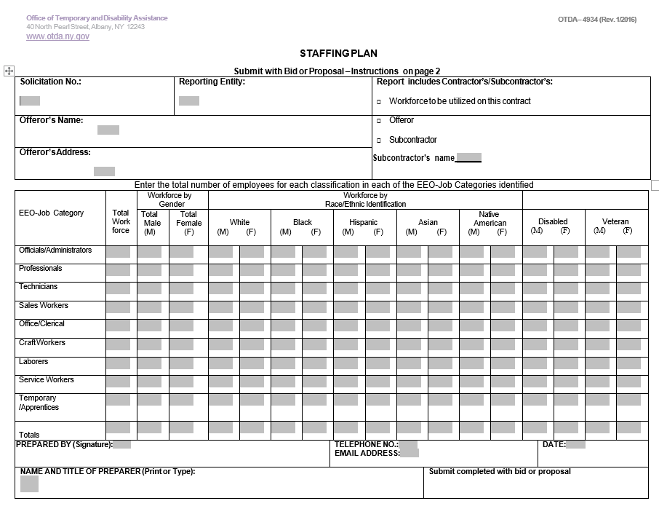
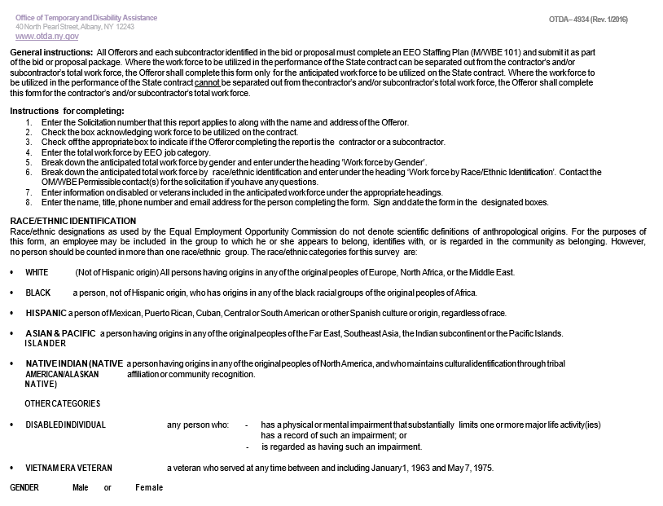
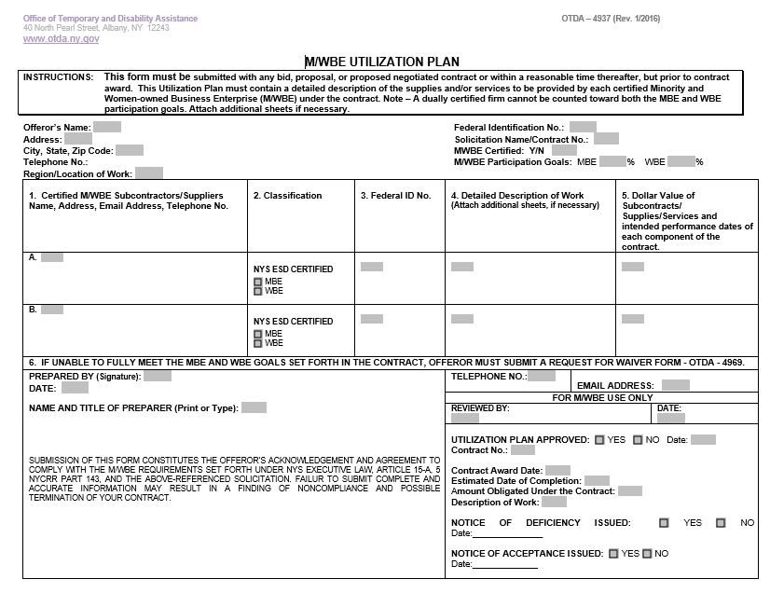

OTDA-4976 (Rev. 1/2016)
M/WBE GOAL REQUIREMENTS
CERTIFICATION OF GOOD FAITH EFFORTS

Contractors (to include those who submit bids/proposals in an effort to be selected for contract award as well as those successful bidders/proposers with whom OTDA enters into State contracts) must document “good faith efforts” to provide meaningful participation by New York State Certified M/WBE subcontractors or suppliers/vendors in the performance of this contract.

The undersigned hereby acknowledges that he/she took or may need to take the following actions on behalf of the Contractor to demonstrate, and upon request by OTDA, to provide written verification to document the aforesaid good faith efforts:
- The Contractor attended any pre-bid, pre-award, or other meetings scheduled by the contracting agency or the NYS Department of Economic Development or its designee to inform certified minority- or women-owned business enterprises of contracting and subcontracting opportunities available on the project, for purposes of complying with contract participation goal requirements;
- The Contractor identified economically feasible units of the project that could be contracted or subcontracted to certified minority- and women-owned business enterprises in order to increase the likelihood of participation by such enterprises on the contract;
- The Contractor undertook efforts to reasonably structure the contract scope of work for purposes of subcontracting with certified minority- and- women-owned business enterprises;
- The Contractor advertised in a timely fashion and in appropriate general circulation, trade and minority- and women-oriented publications, if any, concerning the contracting or subcontracting opportunity;
- The Contractor made written solicitations in a timely fashion to a reasonable number of certified minority- and women- owned business enterprises identified from current certified lists of such business enterprises provided or maintained by the NYS Empire State Development’s Division of Minority and Women Owned Business Development, or its designee, of the contracting or subcontracting opportunity. The directory of certified businesses can be viewed at: http://esd.ny.gov/index.html
- The Contractor can document if any timely responses to any such advertisements and solicitations were provided by certified minority- and women-owned business enterprises;
- The Contractor followed-up initial solicitations by contacting the enterprises to determine whether the enterprises were interested in such contracting or subcontracting opportunity;
- The Contractor provided interested certified minority- and women-owned business enterprises in a timely fashion with adequate information about the plans, specifications or terms and conditions of the State contract and requirements for the contracting or subcontracting opportunity so as to prepare an informed response to a contractor solicitation;
- The Contractor submitted a completed, acceptable utilization plan in accordance with applicable requirements to meet goals for participation of certified minority-and women-owned business enterprises established in the State contract;
- The Contractor used the services of community organizations, contractor groups, state and federal business assistance offices and other organizations identified by the NYS Department of Economic Development or its designee that provide assistance in the recruitment and placement of minority and women business enterprises;
(k) The Contractor negotiated in good faith with certified minority- and women-owned business enterprises submitting bids, proposals, or quotations and did not, without justifiable reason, reject as unsatisfactory any bids, proposals or quotations prepared by any certified minority- or women-owned business enterprise. “Good faith” negotiating means engaging in good faith discussions with certified minority- or women-owned business enterprises about the nature of the work, scheduling, requirements for special equipment, opportunities for dividing of work among the bidders, proposers, and various subcontractors and the bids of the minority or women businesses, including sharing with them any cost estimates from the request for proposal or invitation to bid documents, if available; and,
(l) The Contractor undertook efforts to make payments for any work performed by certified minority- and women-owned business enterprises in a timely fashion so as to facilitate continued performance by certified minority- and women-owned business enterprises.

Signature Date

Print Name

Title

Company

Contract Number

Program/Solicitation Name
USE OF SERVICE-DISABLED VETERAN-OWNED BUSINESSES
Article 17-B of the Executive Law enacted in 2014 acknowledges that Service-Disabled Veteran-Owned Businesses (SDVOBs) strongly contribute to the economies of the State and the nation. As defenders of our nation and in recognition of their economic activity in doing business in New York State, bidders/proposers for this contract for commodities, services or technology are strongly encouraged and expected to consider SDVOBs in the fulfillment of the requirements of the contract. Such partnering may be as subcontractors, suppliers, protégés or other supporting roles. SDVOBs can be readily identified on the directory of certified businesses at https://online.ogs.ny.gov/SDVOB/search.
Bidders/ proposers need to be aware that all authorized users of this contract will be strongly encouraged to the maximum extent practical and consistent with legal requirements of the State Finance Law and the Executive Law to use responsible and responsive SDVOBs in purchasing and utilizing commodities, services and technology that are of equal quality and functionality to those that may be obtained from non-SDVOBs. Furthermore, bidders/proposers are reminded that they must continue to utilize small, minority and women-owned businesses consistent with current State law.
Utilizing SDVOBs in State contracts will help create more private sector jobs, rebuild New York State’s infrastructure, and maximize economic activity to the mutual benefit of the contractor and its SDVOB partners. SDVOBs will promote the contractor’s optimal performance under the contract, thereby fully benefiting the public-sector programs that are supported by associated public procurements.
Public procurements can drive and improve the State’s economic engine through promotion of the use of SDVOBs by its contractors. The State, therefore, expects bidders/proposers to provide maximum assistance to SDVOBs in their contract performance. The potential participation by all kinds of SDVOBs will deliver great value to the State and its taxpayers.
Bidders/ proposers will complete and submit a Service-Disabled Veteran-Owned Business (SDVOB) Utilization Plan (SDVOB-100), to demonstrate their proposed utilization of NYS certified SDVOBs as part of their bid/proposal. However, if after making a good faith effort to achieve the SDVOB participation goal, applicants are unable to achieve the SDVOB participation goal, they may submit an Application for Waiver of SDVOB Participation Goal.

For more detailed information regarding the SDVOB participation requirements, please refer to Appendix E of the RFP.

Note: Information about set asides for SDVOB participation in public procurement can be found https://ogs.ny.gov/veterans/division-service-disabled-veterans-business-development-compliance-and-reporting which provides guidance for State agencies in making determinations and administering set asides for procurements from SDVOBs.
SDVOB-100 (REV. 9/2017)
SDVOB UTILIZATION PLAN |  |  |  |  | Initial Plan |  |  |  |  | Revised plan |  |  |  |  |  | Contract/Solicitation |  |  |  |  | #
INSTRUCTIONS: This Utilization Plan must contain a detailed description of the supplies and/or services to be provided by each NYS Certified Service-Disabled Veteran-Owned Business (SDVOB) under the contract. By submission of this Plan, the Bidder/Contractor commits to making good faith efforts in the utilization of SDVOB subcontractors and suppliers as required by the SDVOB goals contained in the Solicitation/Contract. Making false representations or providing information that shows a lack of good faith as part of, or in conjunction with, the submission of a Utilization Plan is prohibited by law and may result in penalties including, but not limited to, termination of a contract for cause, loss of eligibility to submit future bids, and/or withholding of payments. Firms that do not perform commercially useful functions may not be counted toward SDVOB utilization. Attach additional sheets if necessary.
BIDDER/CONTRACTOR INFORMATION |  |  |  |  |  |  |  |  |  |  |  |  |  |  |  |  | SDVOB Goals In Contract
Bidder/Contractor Name: |  |  |  | NYS Vendor ID: |  |  |  |  |  |  |  |  |  |  |  |  | %
Bidder/Contractor Address (Street, City, State and Zip Code):

Bidder/Contractor Telephone Number: |  |  |  |  |  |  |  |  | Contract Work Location/Region:
Contract Description/Title:
CONTRACTOR INFORMATION
Prepared by (Signature): |  | Name and Title of Preparer: |  |  |  |  |  |  |  |  |  |  | Telephone Number: |  |  |  |  |  | Date:
Email Address:
If unable to meet the SDVOB goals set forth in the solicitation/contract, bidder/contractor must submit a request for waiver on the SDVOB Waiver Form.
SDVOB Subcontractor/Supplier Name:

Please identify the person you contacted: |  |  |  |  |  |  | Federal Identification No.: |  |  |  |  |  |  |  |  | Telephone No.:
Address: |  |  |  |  |  |  | Email Address:
Detailed description of work to be provided by subcontractor/supplier:

Dollar Value of subcontracts/supplies/services (When $ value cannot be estimated, provide the estimated % of contract work the SDVOB will perform): $ or %
SDVOB Subcontractor/Supplier Name:

Please identify the person you contacted: |  |  |  |  |  |  | Federal Identification No.: |  |  |  |  |  |  |  |  | Telephone No.:
Address: |  |  |  |  |  |  | Email Address:
Detailed Description of work to be provided by subcontractor/supplier:

Dollar Value of subcontracts/supplies/services (When $ value cannot be estimated, provide the estimated % of contract work the SDVOB will perform): $ or %
FOR OTDA USE ONLY
OTDA Authorized Signature: |  |  |  |  |  |  |  | Accepted |  |  |  | Accepted as Noted |  |  |  |  |  | Notice of Deficiency
NAME (Please Print): |  |  | SDVOB %/$ |  |  |  |  |  |  |  |  | Date Received: |  |  |  |  |  | Date Processed:
Comments:

NYS CERTIFIED SDVOB SUBCONTRACTOR/SUPPLIER INFORMATION: The directory of New York State Certified SDVOBs can be viewed at: https://online.ogs.ny.gov/SDVOB/search
Note: All listed Subcontractors/Suppliers will be contacted and verified by OTDA
ADDITIONAL SHEET
Bidder/Contractor Name: |  |  |  |  |  |  |  |  |  |  |  |  |  | Contract/Solicitation |  |  |  |  |  | #
SDVOB Subcontractor/Supplier Name:

Please identify the person you contacted: |  |  |  |  |  | Federal Identification No.: |  |  |  |  |  |  |  |  | Telephone No.:
Address: |  |  |  |  |  | Email Address:
Detailed Description of work to be provided by subcontractor/supplier:

Dollar Value of subcontracts/supplies/services (When $ value cannot be estimated, provide the estimated % of contract work the SDVOB will perform): $ or %
SDVOB Subcontractor/Supplier Name:

Please identify the person you contacted: |  |  |  |  |  | Federal Identification No.: |  |  |  |  |  |  |  |  | Telephone No.:
Address: |  |  |  |  |  | Email Address:
Detailed Description of work to be provided by subcontractor/supplier:

Dollar Value of subcontracts/supplies/services (When $ value cannot be estimated, provide the estimated % of contract work the SDVOB will perform): $ or %
SDVOB Subcontractor/Supplier Name:

Please identify the person you contacted: |  |  |  |  |  | Federal Identification No.: |  |  |  |  |  |  |  |  | Telephone No.:
Address: |  |  |  |  |  | Email Address:
Detailed Description of work to be provided by subcontractor/supplier:

Dollar Value of subcontracts/supplies/services (When $ value cannot be estimated, provide the estimated % of contract work the SDVOB will perform): $ or %
SDVOB Subcontractor/Supplier Name:

Please identify the person you contacted: |  |  |  |  |  | Federal Identification No.: |  |  |  |  |  |  |  |  | Telephone No.:
Address: |  |  |  |  |  | Email Address:
Detailed Description of work to be provided by subcontractor/supplier:

Dollar Value of subcontracts/supplies/services (When $ value cannot be estimated, provide the estimated % of contract work the SDVOB will perform)): $ or %
SDVOB Subcontractor/Supplier Name:

Please identify the person you contacted: |  |  |  |  |  | Federal Identification No.: |  |  |  |  |  |  |  |  | Telephone No.:
Address: |  |  |  |  |  | Email Address:
Detailed Description of work to be provided by subcontractor/supplier:

Dollar Value of subcontracts/supplies/services (When $ value cannot be estimated, provide the estimated % of contract work the SDVOB will perform): $ or %

SDVOB-200 (REV. 9/2017)
application for Waiver of SDVOB participation goal
(must be submitted before requesting final payment on the Contract)
Section 1: Basic Information
Contractor’s Name: |  |  |  | Federal Identification Number:
Street Address: |  |  |  | E-Mail Address:
City, State, Zip Code: |  |  |  | Telephone:  ( ) -
Contract Number: |  |  | SDVOB CONTRACT GOALS
 |  |  | %
Section 2: Type of SDVOB Waiver Requested
Total | Partial | If partial waiver, please enter the revised SDVOB percentage: |  |  |  | %
Please explain the reason for the waiver request:
Section 3: Supporting Documentation
Provide the following documentation as evidence of your good faith efforts to meet the SDVOB goals set forth in the contract and in support of your waiver application:
- Attachment A. Copies of solicitations to SDVOBs and any responses thereto.

- Attachment B. Explanation of the specific reasons each SDVOB that responded to Bidders/Contractors’ solicitation was not selected.

- Attachment C. Dates of any pre-bid, pre-award or other meetings attended by Contractor, if any, scheduled by OTDA with certified SDVOBs whom OTDA determined were capable of fulfilling the SDVOB goals set forth in the contract.

- Attachment D. Information describing the specific steps undertaken to reasonably structure the contract scope of work for the purpose of subcontracting with, or obtaining supplies from, certified SDVOBs.

- Attachment E. Other information deemed relevant to the request.
Section 4: Signature and Contact Information
By signing and submitting this form, the contractor certifies that a good faith effort has been made to promote SDVOB participation pursuant to the SDVOB requirements set forth under the solicitation or Contract. Failure to submit complete and accurate information may result in a finding of noncompliance, non-responsibility, and a suspension or termination of the contract.

Prepared By: (Signature) |  |  |  |  | Date:
Name and Title of Preparer (Print or Type)

SDVOB-200 (REV. 9/2017)
For OTDA Use Only
Reviewed By: | Date:
Decision:

Full SDVOB waiver granted
Partial SDVOB waiver granted; revised SDVOB goal: _______ %
SDVOB waiver denied

Approved By: | Date:
Date Notice of Determination Sent:

Comments

EXHIBIT D-3:
Required Certifications

Vendor Responsibility Questionnaire (AC 3291-S)

Nondiscrimination in Employment in Northern Ireland

Non-Collusive Bidding Certification

Agreement

Vendor Assurance of No Conflict of Interest or Detrimental Effect (see Appendix L of the RFP)
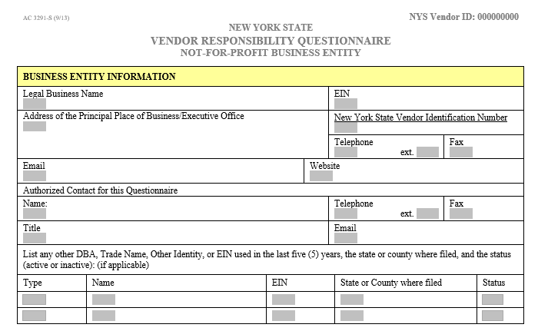

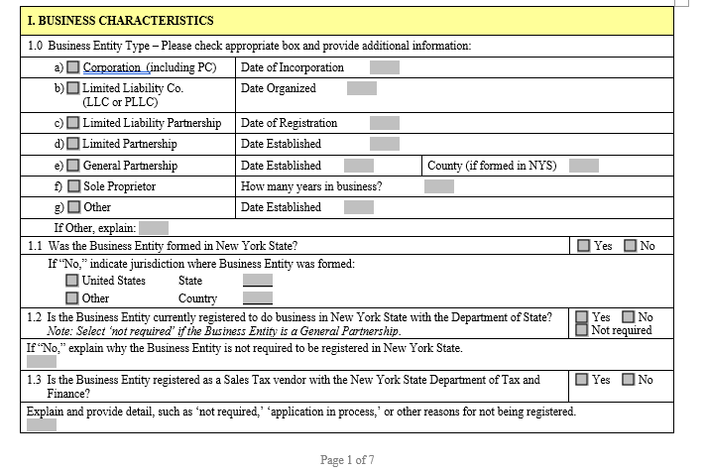

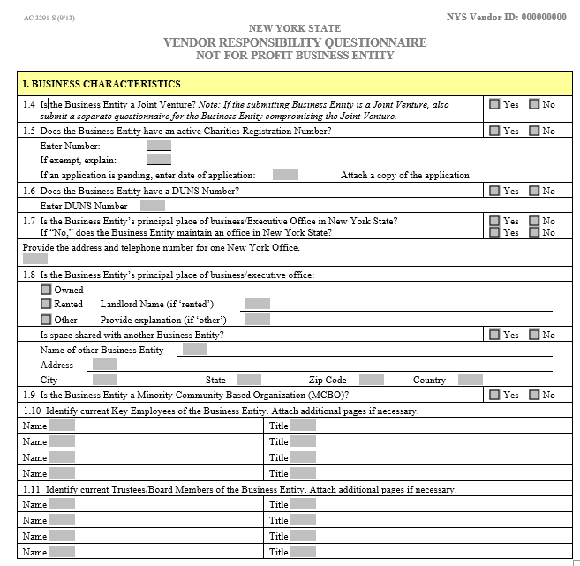
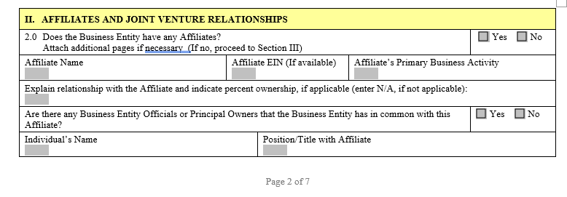

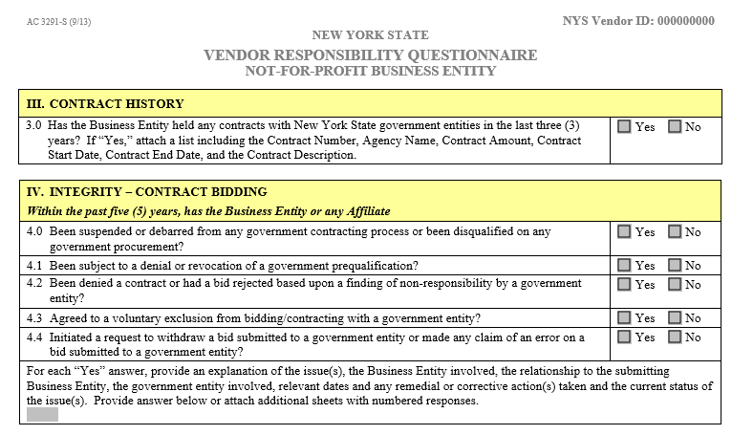
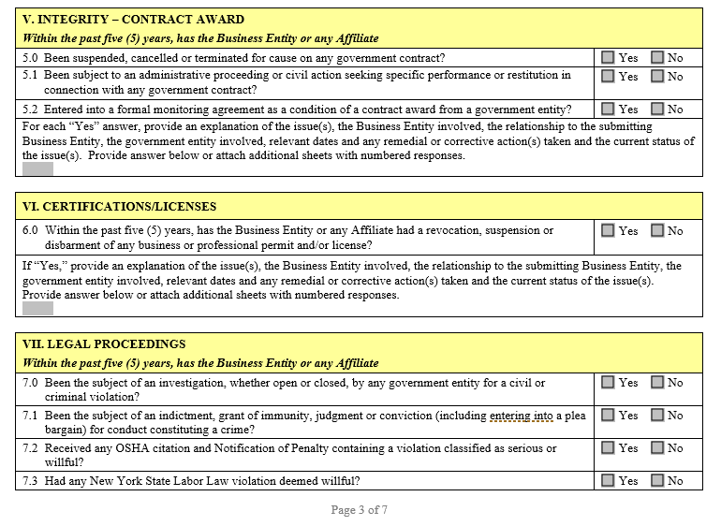

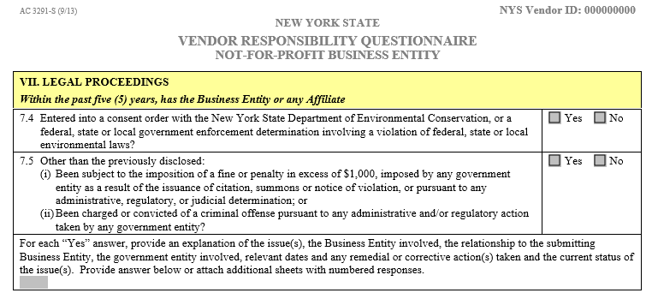
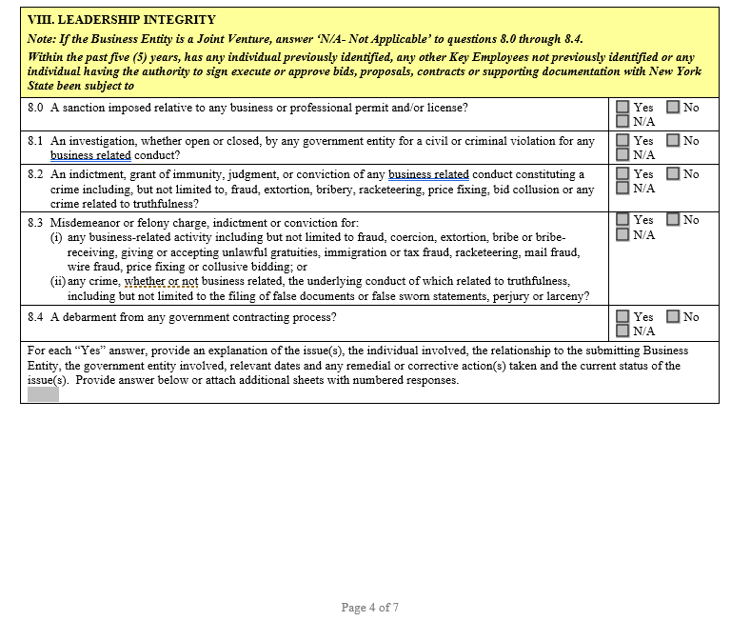

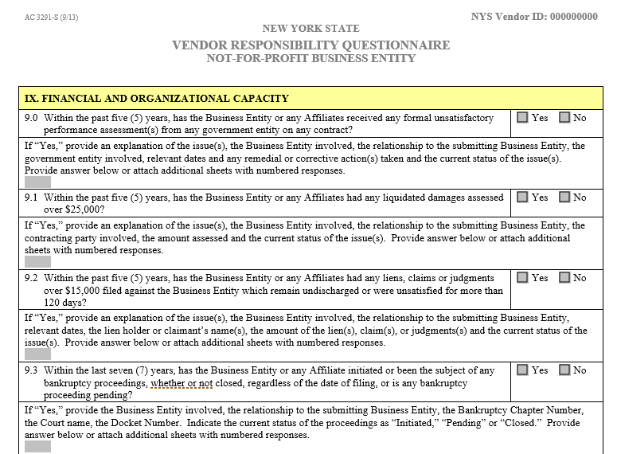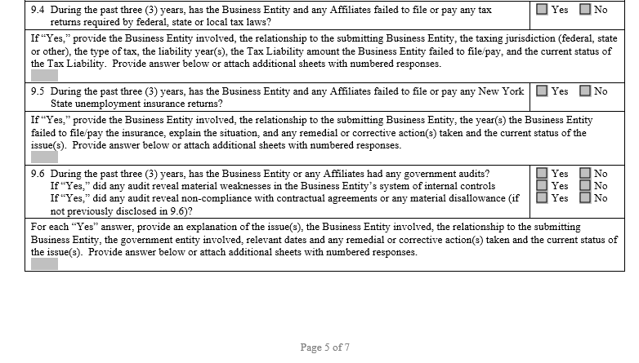

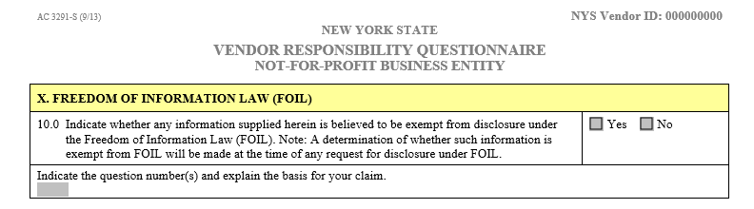

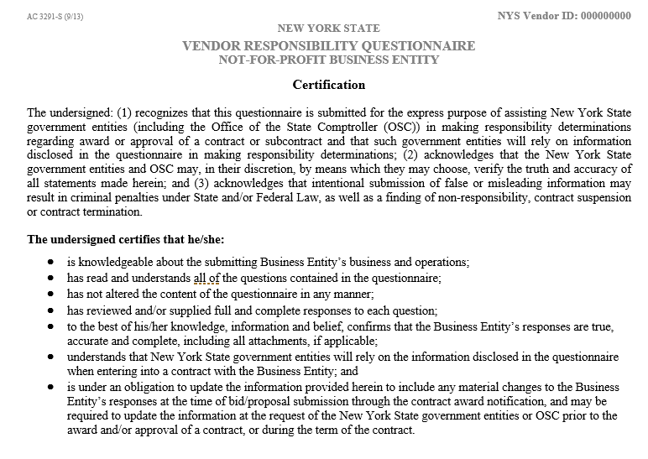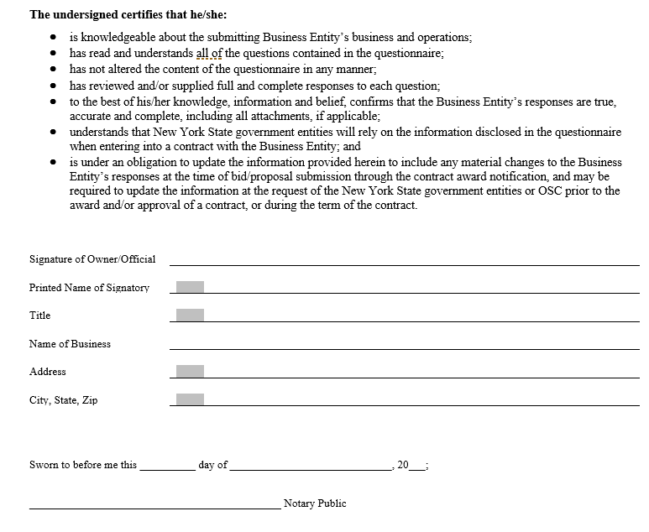
Nondiscrimination in Employment in
Northern Ireland:
MacBride Fair Employment Principles

In accordance with section 165 of the State Finance Law, the bidder, by submission of this bid certifies that it or any individual or legal entity in which the bidder holds a 10% or greater ownership interest, or any individual or legal entity that holds a 10% or greater ownership in the bidder, either: (answer yes or no to one or both of the following, as applicable):

- Has business operations in Northern Ireland

Yes No

if yes,

- Shall take lawful steps in good faith to conduct any business operations that it has in Northern Ireland in accordance with the MacBride Fair Employment Principles relating to nondiscrimination in employment and freedom of workplace opportunity regarding such operations in Northern Ireland and shall permit independent monitoring of their compliance with such Principles.

Yes No

Signature
Non-Collusive Bidding Certification Required
by Section 139-D of the State Finance Law (Page 1 of 2)

SECTION 139-D. Statement of Non-Collusion in Bids to the State:

BY SUBMISSION OF THIS BID, BIDDER AND EACH PERSON SIGNING ON BEHALF OF BIDDER CERTIFIES, AND IN THE CASE OF A JOINT BID, EACH PARTY THERETO CERTIFIES AS TO ITS OWN ORGANIZATION, UNDER PENALTY OR PERJURY, THAT TO THE BEST OF HIS/HER KNOWLEDGE AND BELIEF:

[1] The prices of this bid have been arrived at independently, without collusion, consultation, communication, or agreement, for the purposes of restricting competition, as to any matter relating to such prices with any other Bidder or with any competitor;

[2] Unless otherwise required by law, the prices which have been quoted in this bid have not been knowingly disclosed by the Bidder and will not knowingly be disclosed by the bidder prior to opening, directly or indirectly, to any other bidder or to any competitor; and

[3] No attempt has been made or will be made by the Bidder to induce any other person, partnership or corporation to submit or not to submit a bid for the purpose of restricting competition.

A BID SHALL NOT BE CONSIDERED FOR AWARD NOR SHALL ANY AWARD BE MADE WHERE [1], [2] AND [3] ABOVE HAVE NOT BEEN COMPLIED WITH; PROVIDED HOWEVER, THAT IF IN ANY CASE THE BIDDER(S) CANNOT MAKE THE FOREGOING CERTIFICATION, THE BIDDER SHALL SO STATE AND SHALL FURNISH BELOW A SIGNED STATEMENT WHICH SETS FORTH IN DETAIL THE REASONS THEREFORE:

[AFFIX ADDENDUM TO THIS PAGE IF SPACE IS REQUIRED FOR STATEMENT]

Subscribed to under penalty of perjury under the laws of the State of New York, this _____ day of ________________________, 20___ as the act and deed of said corporation or partnership.

Potential Contractor:

Address:
Street City State Zip

Telephone: Title:

If applicable, responsible Corporate Officer

Name: Title:

Signature: ____________________________________________________________________

JOINT OR COMBINED BIDS MUST BE CERTIFIED ON BEHALF OF EACH PARTICIPANT.

_______________________________ _______________________________
Legal name of person, firm or corporation Legal name of person, firm or corporation

By: ____________________________ By: ____________________________
Name Name

_______________________________ ________________________________
Title Title

_______________________________ ________________________________
Street Address Street Address

_______________________________ _________________________________
City/State City/State

Agreement

It is understood and agreed to by the applicant and co-applicant, if and, that: (1) Applicant organization meets the requirements of a local recipient organization. It is a municipality, non-profit corporation or charitable organization, has an accounting system, and practices non-discrimination. (2) Funds received from the New York State Homeless Housing and Assistance Program will be expended in accordance with the state guidelines established for such purposes. (3) The organization agrees to comply with the requirements of the Civil Rights Act of 1964 as amended, and all applicable Federal Regulations contained in 44 CFR, Part 7, entitled “Nondiscrimination in Federally-Assisted Programs,” and agrees that the expression of religious belief or religious activity shall not be a condition to receiving shelter or services. (4) The funds may be terminated in whole, or in part, by the Commissioner of the New York State Office of Temporary & Disability Assistance. Such termination shall not affect obligations incurred under the contract prior to the effective date of such termination. (5) When funds are advanced, any unexpended balance at the end of the approval period will be returned. (6) Any significant revision of the approved project proposal will be requested in writing by the awardee prior to the enactment of the change. (7) Progress reports will be submitted as required by the HHAC. The final program and financial reports will be submitted as required by the HHAC. Final program and financial reports will be submitted within one month after the project terminates. All necessary records and accounts, including financial and property controls, will be maintained and made available to the New York State Office of Temporary & Disability Assistance for audit purposes. (8) All reports of investigations, studies, publications, etc., made as a result of this proposal will acknowledge the support provided by the New York State Office of Temporary & Disability Assistance and the Homeless Housing and Assistance Corporation. (9) All personal information concerning individuals served or studied under the project is confidential and such information may not be disclosed to unauthorized persons. (10) The New York State Office of Temporary & Disability Assistance and Homeless Housing and Assistance Corporation reserve a royalty-free non-exclusive license to use and authorize others to use all copyrighted material resulting from this project. (11) The applicant shall comply with all program requirements stated in this Request for Proposals, and with all applicable laws and regulations, in establishing and operating its Homeless Project.

The applicant and co-applicant, if any, certifies that to the best of its knowledge and belief the data in this application are true and correct, that it will comply with the above agreement if it receives funding, and that this constitutes a firm offer for 150 days.

_________________________________________________________________________
APPLICANT AGENCY

SIGNATURE OF OFFICIAL AUTHORIZED TO SIGN FOR APPLICANT

__________ _________________________________________
Date TITLE

_________________________________________________________________________

CO-APPLICANT AGENCY

SIGNATURE OF OFFICIAL AUTHORIZED TO SIGN FOR CO-APPLICANT

__________ ____________________________________________
Date TITLE

Vendor Assurance of No Conflict of Interest or Detrimental Effect (Page 1 of 2)
(Version 1 - 2019 RFP)

The Applicant offering to provide services pursuant to this Homeless Housing and Assistance Corporation (“HHAC”) RFP, as a contractor, joint venture contractor, subcontractor, or consultant, attests that its performance of the services outlined in this RFP does not and will not create a conflict of interest with nor position the Applicant to breach any other contract currently in force with the State of New York.

Furthermore, the Applicant attests that it will not act in any manner that is detrimental to any State or HHAC project on which the Applicant is rendering services. Specifically, the Applicant attests that:

1. The fulfillment of obligations by the Applicant, as proposed in the RFP response, does not violate any existing contracts or agreements between the Applicant and the State or HHAC;

2. The fulfillment of obligations by the Applicant, as proposed in the RFP response, does not and will not create any conflict of interest, or perception thereof, with any current role or responsibility that the Applicant has with regard to any existing contracts or agreements between the Applicant and the State or HHAC;

3. The fulfillment of obligations by the Applicant, as proposed in the RFP response, does not and will not compromise the Applicant’s ability to carry out its obligations under any existing contracts between the Applicant and the State and HHAC;

4. The fulfillment of any other contractual obligations that the Applicant has with the State or HHAC will not affect or influence its ability to perform under any contract with the State or HHAC resulting from this RFP;

5. During the negotiation and execution of any contract resulting from this RFP, the Applicant will not knowingly take any action or make any decision which creates a potential for conflict of interest or might cause a detrimental impact to the State or HHAC as a whole including, but not limited to, any action or decision to divert resources from one State or HHAC project to another;

6. In fulfilling obligations under each of its State contracts, including any contract which results from this RFP, the Applicant will act in accordance with the terms of each of its State or HHAC contracts and will not knowingly take any action or make any decision which might cause a detrimental impact to the State or HHAC as a whole including, but not limited to, any action or decision to divert resources from one State or HHAC project to another;

7. No former officer or employee of the State who is now employed by the Applicant, nor any former officer or employee of the Applicant who is now employed by the State, has played a role with regard to the administration of this contract procurement in a manner that may violate section 73(8)(a) of the State Ethics Law; and

8. The Applicant has not and shall not offer to any employee, member or director of the State any gift, whether in the form of money, service, loan, travel, entertainment, hospitality, thing or promise, or in any other form, under circumstances in which it could reasonably be inferred that the gift was intended to influence said employee, member or director, or could reasonably be expected to influence said employee, member or director, in the performance of the official duty of said employee, member or director or was intended as a reward for any official action on the part of said employee, member or director.

Applicants responding to this RFP should note that the State and HHAC recognize that conflicts may occur in the future because a Applicant may have existing or new relationships. HHAC will review the nature of any such new relationship and reserves the right to terminate the contract for cause if, in its judgment, a real or potential conflict of interest cannot be cured.

Name, Title:

Signature: Date:

This form must be signed by an authorized executive or legal representative.

EXHIBIT E-1: Site Description
(Duplicate this page for each building in the proposed project) (Page 1 of 2)
Please refer to Appendix A: Technical Submission Guidelines and Requirements for Exhibit E, and Appendix B: Architect’s Certification

Site of

Site Address:

- Former use of Building or Site which is intended to be the site of the proposed project.

Hotel/Motel SRO/Lodging House
Multiple Family Dwelling Single Family Dwelling
Institution Commercial/Industrial, Specify:
Vacant Land Other, Specify:

Note: The Phase I Environmental Site Assessment (ESA) should be included where known site conditions or a known previous use of the site is indicative of potential hazardous materials, soil or water contamination, underground storage tanks, asbestos, mold and/ or lead based paint. If no Phase I is planned, please confirm that there are no environmental concerns at the site.

- Describe the design and current condition of the project premises, including soil conditions, topography, wetlands, and the existence of asbestos, lead paint, and/or any hazardous material. If a Phase I ESA has been conducted and Phase II ESA is recommended, the results of both reports should also be included with the application.

- Describe how subsurface conditions were considered, and the efforts to investigate any known or suspected conditions on or near the site that may impact the cost and development of the project. For example, include the number and location of borings (if applicable), or other information to be relied on. Attach and label any available supplemental material such as geo-technical proposals or surveys conducted. Note that failure to adequately investigate or plan for subsurface conditions may result in the rejection of the proposal, or the rescinding of an HHAP award.

- Describe the characteristics of the surrounding area and the approximate age, condition and architectural design of structures in the immediate neighborhood.

- Detail the proximity of this site to public transportation, community and municipal services, day care, shopping and medical services, etc.

- Describe any housing and/or services that will be provided to a non-homeless population at this site.

EXHIBIT E-1: Site Description (Page 2 of 2)
(Duplicate this page for each building in the proposed project)

- Describe any plans to relocate current tenants (if any) from this site or integrate them into the proposed project.

Add additional sheets if needed and label Project Site Information
EXHIBIT E-2: Site Development Information
(If more than one site, whether identified or not, duplicate this exhibit for each building
in the proposed project and provide a summary of E-2 pages 1 and 2
setting forth cumulative information.)
(Page 1 of 4)

Architectural or Engineering Firm:

Name of Architect/Engineer:

Address/Phone Number:

NYS Architectural License #:

WBE MBE NYS Certified? Yes No

Site of

Site Address: City: Zip Code:

Date(s) of Site Inspection:

Number of floors in building including basement:

Dwelling Units by Size

Type of Unit | Number of  HHAP  Units | Number of  Non-HAP  Units | Total Units | Average Square Footage per Unit |  |  | Total  Square Footage
SRO
Studio/Efficiency
One-Bedroom
Two-Bedroom
Three-Bedroom
Four-Bedroom
Five Bedroom
Congregate *
Total Residential Square Footage
*Refer to Definitions section of this application, pages 7-9

EXHIBIT E-2: Site Development Information
(Page 2 of 4)

Site of

Site Address: City: Zip Code:

1. Total square footage of congregate dining areas/kitchens common living rooms, lounges and other public rooms

2. Total square footage of social service and ancillary service space directly serving building residents (describe)

3. Total square footage of commercial space
4. Total square footage of circulation, mechanical, other (specify)

TOTAL OF LINES 1-4

5. Total residential square footage from E-2, page 1

TOTAL GROSS SQUARE FOOTAGE TO BE CONSTRUCTED/ IMPROVED
(Total of lines 1-5. This figure should be the same as in Exhibit E-3, page 4)
- Total gross square footage of area NOT to be improved (describe)

Total Gross Square Footage of Building after Completion:
(Total of lines 1-6. This figure should be the same as in Exhibit E-3, page 4)

EXHIBIT E-2: Site Development Information
(Page 3 of 4)

Site of

Site Address: City: Zip Code:

List Below the Available Utilities and Other Public Infrastructure.

Certificate of Occupancy (If existing C of O is available, please attach copy)

- Existing Certificate of Occupancy for (use, number of units, size, occupancy class)

- Proposed Occupancy (occupancy class, number of units, size)

- Is a new Certificate of Occupancy expected to be issued or required at the completion of construction?

Yes No

If no, please explain below.

Accessibility for Persons with Disabilities

Which state and/or local building code provision(s) governs handicapped accessibility for this site?

What, in summary, is required by this code?

What is proposed?

EXHIBIT E-2: Site Development Information
(Page 4 of 4)

Site of

Site Address: City: Zip Code:

Proposed Building Construction Classification

New York State Code New York City Code

Check One Below:

1a IA IC Fire Resistive
1b IB ID

2a IE Non-Combustible

3 IIA Heavy Timber

4a IIB Ordinary
4b IIC

5a IID Wood Frame
5b IIE

In summary, what constraints does this construction place on the proposed building (e.g., sprinklers required, additional egress, horizontal or vertical separation)?

EXHIBIT E-3:
Scope of Work and Cost Estimate (Page 1 of 4)
(If more than one site, duplicate this section for each building in the proposed project.)

Site of

Site Address:

Level of Construction Work Required

Acquisition Only Moderate Rehabilitation
Substantial Rehabilitation New Construction

Project will be Constructed by:

General Contractor Selected via Bid; or

Preselected* General Contractor (GC); or

Construction Manager^ Selected via Bid; or

Preselected Construction Manager*^(CM) with Subcontractors Selected via Bid; or

Other, specify:

If proposing a preselected construction manager or contractor, identify the individual or firm below and provide contact and other information as required in Exhibit A-6. In addition, please provide justification for utilizing the services of a preselected GC or CM and indicate whether the firm is a M/WBE or SDVOB.

WBE MBE NYS Certified? Yes No

SDVOB NYS Certified? Yes No

*Note: HHAC may require that 50% of the value of the work is competitively bid, which may be accomplished through trade subcontractors. In lieu of bidding 50% of the total construction value HHAC may, at its discretion, accept a bid plan and matrix for review and approval. If there is an identity of interest among a sponsor/owner development team and the pre-selected general contractor or construction manager, HHAC may, in its sole discretion, require that all trades or subcontracts be competitively bid.

*Note: HHAC will not entertain utilizing the services of a Construction Manager as Advisor (CMA); HHAC will only consider utilizing the services of a Construction Manager as Constructor (CMC).

EXHIBIT E-3: Scope of Work and Cost Estimate
(Page 2 of 4)

Site of
Site Address:

Scope of Work

- Based on the current condition of the building as described in Exhibit E-1, provide a narrative scope of work describing, in detail, construction work to be performed. The scope of work for rehabilitation projects should be comprehensive and should address each significant building component and state whether it is to be repaired and/ or replaced and to what extent. The scope should cover heating and ventilation; domestic hot water; electrical; gas; plumbing; elevators; sprinklers; kitchens and baths, including fixtures, cabinets, and appliances; windows and doors; interior finishes; public spaces; security systems; lead and asbestos; roof; building structure and building envelope. The narrative should address whether the capacity, age, and effectiveness of existing systems was considered.

- Be sure to address site conditions, such as soil, hazardous materials, and predictable subsurface conditions such as rock and groundwater, wetlands, etc. based on a due diligence review of available information, as appropriate. Identify any areas not accessible for inspection, provide an analysis of potential implications and an estimate of related additional costs.

- Please attach outline specifications detailing the proposed construction work. Again, refer to Appendix A: Technical Submission Guidelines and Requirements for Exhibit E.

- In addition, provide a detailed estimate of the cost of construction by Construction Standards Institute (CSI) category (format provided following this page). Please note that while HHAP funding does not trigger prevailing wage requirements, some other funding sources may. Indicate below whether the attached cost estimate is based on prevailing wages.

- Please provide an explanation of how life-cycle costs were considered in developing the scope of work in terms of durability of materials and equipment, cost and ease of maintenance and operations.

- Also, provide a brief narrative describing how the design in general is appropriate for the proposed population. If applicable, describe what aspects of the design or work proposed are beneficial to the population to be served, and how.

The construction cost estimate is is not based on prevailing wages.

An incomplete response to this section may result in the disqualification of the proposal.
EXHIBIT E-3: Scope of Work and Cost Estimate
(Page 3 of 4)

FOR PRESERVATION OF OPERATING HHAP PROJECTS ONLY:

- If requesting funds for the preservation of an Operating HHAP Project, describe how the scope was determined and limited to the items and conditions that, if not corrected, will impact the health and safety of tenants and/or the ongoing viability of the project.

- For Operating HHAP Projects, if applicable, the narrative must also describe how the scope of work is limited to those repairs, expansion of units, or other modifications necessary to:

(a) Enhance the quality of life or facilitate appropriate supportive services for tenants;

(b) Accommodate population changes in response to community needs; and/or

(c) Address one or more significant operational issues that are related to sustaining the availability of the project as a community resource for homeless individuals and/or families.

EXHIBIT E-3: Scope of Work and Cost Estimate (Page 4 of 4)
(If more than one site, duplicate this page for each building in the proposed project
and provide a summary page setting forth cumulative cost information.)

Site of

Site Address:

Division 1 General Requirements $0
Division 2 Demolition and Site Work $0
Division 3 Concrete $0
Division 4 Masonry $0
Division 5 Metals $0
Division 6 Wood & Plastic $0
Division 7 Thermal & Moisture Protection $0
Division 8 Doors & Windows $0
Division 9 Finishes $0
Division 10 Specialties $0
Division 11 Equipment $0
Division 12 Furnishings $0
Division 13 Special Construction $0
Division 14 Conveying systems $0
Division 15 Mechanical $0
Division 16 Electrical $0

Total Building Construction Cost (without contingency) $0
(this figure should be transferred to Exhibit B-1, Line C.1)

(Includes % General Conditions, % Overhead, % Profit)

Construction Change Order Contingency $0
(10% for Rehabilitation; 5% for New Construction)

Total Construction Cost $0

Total gross square footage to be constructed/improved 0
(this figure should be the same as Exhibit E-2, page 2)

Construction Cost (without contingency) divided by GSF $ /GSF

EXHIBIT E-4:
Energy Efficiency (Page 1 of 2)

Proposals should demonstrate that the project will incorporate measures to achieve high energy efficiency. Proposals may meet this requirement by one of the following methods, as applicable to the project. Please indicate below which of the following are attached.

- For applicants participating in the New York State Energy Research and Development Authority (NYSERDA) Multifamily Performance Program:

Letter of Interest/Partner Letter from NYSERDA.

A copy of a signed contract with a NYSERDA-approved Performance Partner.

*Please note that if the NYSERDA rebate is less than the cost of energy consultant, HHAP may not pay for the consultant and points may not be awarded.

- For applicants Participating in NYSERDA’s New Construction Housing Programs (applicants must achieve either the New York ENERGY STAR Certified Homes or the New York Energy $mart designation):

A copy of a signed contract with a Builder or a Home Energy Rating System (HERS) Rater who participates in NYSERDA’s program; OR

A HERS-based plan review completed by a participating HERS rater to affirm the project design will meet the high efficiency guidelines required to meet NYSERDA’s program requirements.

*Please note that if the NYSERDA rebate is less than the cost of the energy consultant, HHAP may not pay for the consultant and points may not be awarded.

- For applicants participating in NYSERDA’s Home Performance with ENERGY STAR Program:

A copy of a signed contract with a participating Home Performance contractor that commits to complying with the requirements of the program.

*Please note that if the NYSERDA rebate is less than the cost of the energy consultant, HHAP may not pay for the consultant and points may not be awarded.

- For applicants committing to design the project in conformance with the U. S. Environmental Protection Agency (EPA) ENERGY STAR Multifamily High-Rise Program (version 1.0, in either the prescriptive path or the performance path to achieve a 15% improvement in energy efficiency beyond that required by the American Society of Heating, Refrigerating and Air Conditioning Engineers (ASHRAE) 90.1-2016 baseline):

A copy of a signed contract with an energy consultant which explains the methodology to be utilized to ensure that the standard is met.

- For applicants committing to design the project in conformance with EPA ENERGY STAR New Homes (version 3.0, in either the prescriptive path or the performance path):

A copy of a signed contract with a RESNET certified HERS Rater which explains the methodology to be utilized to ensure that the standard is met.

EXHIBIT E-4:
Energy Efficiency (Page 2 of 2)

- For rehabilitation projects, applicants committing to design an existing non-complaint building(s) to meet current energy code standards (the Energy Conservation Construction Code of New York State 2010):

Evidence that that the renovated building(s) will reduce overall energy usage by 20%, as compared to average energy usage for the last two years of operation. The projected reduction in energy usage must be demonstrated by submitting an energy analysis by an architect or engineer licensed in the State of New York, or RESNET certified HERS Rater.

- None of the above alternatives are applicable to the project:

A narrative and supporting documentation evidencing that the proposed project will incorporate measures to achieve high energy efficiency.

This project does not incorporate specific Energy Efficiency measures.

EXHIBIT E-5:
Zoning Analysis and Status of Local Approvals
(If more than one site, duplicate this page for each building in the proposed project.)

Site of

Site Address:

Zoning Analysis

Current Zoning (attach map)

Permitted Uses (attach applicable excerpt of regulations)

This Use

What is permitted floor area? (Most conservative estimate)

Does the proposed design and density conform to local zoning? If not, describe the situation and explain why the project cannot be re-designed to be “as of right”.

If a zoning change, variance, special use permit or other related approval is required for the project to operate, explain the action and the time required to accomplish such a change or gain approval. Attach evidence that the local planning or building authority has been notified of the intent to seek the change or approval, that the action has been applied for, and, if already approved, evidence of such approval.

Access Agreements

List below any Access Agreements that are necessary to develop the proposed project and describe the current status of such agreements. Following this page, attach documentation of all agreements that are executed or in final form.

Status of Local Approvals

List below the local approvals necessary to develop the proposed project and describe the current status of such approvals and whether any requests for approval have been denied. Following this page, attach documentation of all approvals that have been granted or denied.

EXHIBIT E-6:
Project Timeline

Please estimate the total timeframe (in months) for development of the proposed project from notification of award to project rent up and provide the estimated month and year for achieving major project milestones in the chart below. Please add additional milestones as appropriate.

Total Timeframe for Development (in months):

Milestone | Status | Contact Person  and Phone Number | Estimated Date of  Completion  (Month/ Year)
Site Acquisition
Development Funding Commitments
(other than HHAP)
Operating Funding Commitments
Code Variance
Area Variance
Change in Use Permit
Easement
Use Variance
Other (specify)
Site Plan Approval
Zoning Approval
SHPO Determination
Design Phase
Bid and Award
Construction Finance closing
Building Permit Secured
Construction Start
Construction Complete/
Certificate of Occupancy
Execution of Operating Funding Contracts (e.g. ESSHI, if applicable)
Project Rent-Up Begins
Project Rent-Up Completed

EXHIBIT E-7:
State Historic Preservation Office (SHPO) Submission and
State Environmental Quality Review (SEQR)
(Page 1of 2)
1. All applicants must complete the SHPO’s online CRIS process on the State Office of Parks, Recreation and Historic Preservation’s website for eligibility review prior to submitting the application. Please submit all projects directly into CRIS. You will find a link to the system and a link to a tutorial on their website at -- www.nysparks.com/shpo/online-tools/.

While you can submit projects as a guest, registering will save time in the future if you are going to be working with the system on a long-term basis. See information at the end regarding registration. Several tips:
- Begin by using the “Submit” tab on the landing page and choosing “Consultation Project.”
- Please include contact information for anyone who should receive communication about findings, and that includes staff at any permitting or funding agency (*Please specify that an application is being submitted to HHAP). For SEQRA submissions, it is important to include a contact for the municipality, such as the chair of the planning board and/or planning staff.
- For projects submitted as a SEQRA Lead Agency notice, please clarify whether there will be additional permits or sources of funding involved in future phases of the project. If it is likely that the development will require a state or federal permit in a later phase (such as a DEC or Army Corps permit) we may review the project under Section 14.09 or 106. Provide contact information for the agency or agencies involved.
- Always provide a description of the project. When uploading materials, be sure to wait until Step 5 to submit your project documents such as a scope of work and maps.
- Under the Built Resources section, place the photos for any buildings. Do not place any scopes of work or maps in this section but wait until Step 5. When uploading photos and materials for buildings, include any outbuildings or related structures under the same resource. Do not create a separate built resource entry for garages, sheds, walls. etc.
- If you have a question regarding a project and would like to check with SHPO staff before submitting materials, you will be able to find contacts for each county at http://nysparks.com/shpo/contact/.
SHPO currently recommends that new registered users create personal NY.gov ID accounts (rather than business or government ID accounts) using their preferred email address for SHPO correspondence, since personal accounts do not require agency approval to activate. Some agencies’ services distinguish the three different account types, but CRIS does not.

The first time you log into CRIS with a NY.gov ID account, you will automatically be added to the CRIS user database. After you have logged in, you may click the My Profile link in the upper right corner of the CRIS page to edit your contact information (such as organization, address, and phone number). This information will automatically be entered in the primary contact form when you start a new submission.

If you need assistance using CRIS, contact the help desk at CRISHelp@parks.ny.gov.

EXHIBIT E-7:
State Historic Preservation Office (SHPO) Submission And
State Environmental Quality Review (SEQR)
(Page 2 of 2)

Please include in your application proof of the electronic submission to CRIS.

- If the project site is a historic building or in a historic district, what impact will this have on project cost and design? Has either local landmarks or State Historic Preservation been consulted on this project? If so, describe any comments/concerns identified and how they will be addressed.

- Submission of the short Environmental Assessment Form (EAF provided) with the application is required for compliance with the State Environmental Quality Review Act (SEQRA) procedures. The applicant is responsible for completing only Part 1 of the three-part form. The Lead Agency will complete Parts 2 and 3, as necessary.

Short Environmental Assessment Form

Instructions for Completing

Part 1 - Project Information. The applicant or project sponsor is responsible for the completion of Part 1. Responses become part of the application for approval or funding, are subject to public review, and may be subject to further verification. Complete Part 1 based on information currently available. If additional research or investigation would be needed to fully respond to any item, please answer as thoroughly as possible based on current information.

Complete all items in Part 1. You may also provide any additional information which you believe will be needed by or useful to the lead agency; attach additional pages as necessary to supplement any item.

Part 1 - Project and Sponsor Information
Name of Action or Project:
Project Location (describe, and attach a location map):
Brief Description of Proposed Action:
Name of Applicant or Sponsor: | Telephone:
 | E-Mail:
Address:
City/PO: |  | State: | Zip Code:
1. Does the proposed action only involve the legislative adoption of a plan, local law, ordinance, administrative rule, or regulation?  If Yes, attach a narrative description of the intent of the proposed action and the environmental resources that may be affected in the municipality and proceed to Part 2. If no, continue to question 2. |  |  |  | NO | YES
2. Does the proposed action require a permit, approval or funding from any other governmental Agency? If Yes, list agency(s) name and permit or approval: |  |  |  | NO | YES
3.a. Total acreage of the site of the proposed action? acres
- Total acreage to be physically disturbed? acres
- Total acreage (project site and any contiguous properties) owned
or controlled by the applicant or project sponsor? acres
4. Check all land uses that occur on, adjoining and near the proposed action.
□ Urban □ Rural (non-agriculture) □Industrial □ Commercial □ Residential (suburban)
□ Forest □ Agriculture □ Aquatic □ Other (specify):
□Parkland

- Is the proposed action,  - A permitted use under the zoning regulations?  - Consistent with the adopted comprehensive plan? | NO | YES | N/A
6. Is the proposed action consistent with the predominant character of the existing built or natural landscape? |  | NO | YES
7. Is the site of the proposed action located in, or does it adjoin, a state listed Critical Environmental Area? If Yes, identify: |  | NO | YES
- a. Will the proposed action result in a substantial increase in traffic above present levels?  - Are public transportation service(s) available at or near the site of the proposed action?  - Are any pedestrian accommodations or bicycle routes available on or near site of the proposed action? |  | NO | YES
9. Does the proposed action meet or exceed the state energy code requirements?  If the proposed action will exceed requirements, describe design features and technologies: |  | NO | YES
10. Will the proposed action connect to an existing public/private water supply?  [If Yes, does the existing system have capacity to provide service? □ NO □ YES]  If No, describe method for providing potable water: |  | NO | YES
11. Will the proposed action connect to existing wastewater utilities?  [If Yes, does the existing system have capacity to provide service? □ NO □ YES]  If No, describe method for providing wastewater treatment: |  | NO | YES
12. a. Does the site contain a structure that is listed on either the State or National Register of Historic Places?  b. Is the proposed action located in an archeological sensitive area? |  | NO | YES
13. a. Does any portion of the site of the proposed action, or lands adjoining the proposed action, contain wetlands or other waterbodies regulated by a federal, state or local agency?  b. Would the proposed action physically alter, or encroach into, any existing wetland or waterbody?  If Yes, identify the wetland or waterbody and extent of alterations in square feet or acres: |  | NO | YES
- Identify the typical habitat types that occur on, or are likely to be found on the project site. Check all that apply:
  - Shoreline □ Forest □ Agricultural/grasslands □ Early mid-successional
  - Wetland □ Urban □ Suburban
15. Does the site of the proposed action contain any species of animal, or associated habitats, listed by the State or Federal government as threatened or endangered? |  | NO | YES
16. Is the project site located in the 100 year flood plain? |  | NO | YES
- Will the proposed action create storm water discharge, either from point or non-point sources? If Yes,  - Will storm water discharges flow to adjacent properties? □ NO □ YES  - Will storm water discharges be directed to established conveyance systems (runoff and storm drains)? If Yes, briefly describe: □ NO □ YES |  | NO | YES

18. Does the proposed action include construction or other activities that result in the impoundment of water or other liquids (e.g. retention pond, waste lagoon, dam)?  If Yes, explain purpose and size: | NO | YES
19. Has the site of the proposed action or an adjoining property been the location of an active or closed solid waste management facility?  If Yes, describe: | NO | YES
20. Has the site of the proposed action or an adjoining property been the subject of remediation (ongoing or completed) for hazardous waste?  If Yes, describe: | NO | YES
I AFFIRM THAT THE INFORMATION PROVIDED ABOVE IS TRUE AND ACCURATE TO THE BEST OF MY KNOWLEDGE
Applicant/sponsor name: Date: Signature:

Part 2 - Impact Assessment. The Lead Agency is responsible for the completion of Part 2. Answer all of the following questions in Part 2 using the information contained in Part 1 and other materials submitted by the project sponsor or otherwise available to the reviewer. When answering the questions, the reviewer should be guided by the concept “Have my responses been reasonable considering the scale and context of the proposed action?”

 |  | No, or small impact may occur | Moderate to large impact may occur
1. | Will the proposed action create a material conflict with an adopted land use plan or zoning regulations?
2. | Will the proposed action result in a change in the use or intensity of use of land?
3. | Will the proposed action impair the character or quality of the existing community?
4. | Will the proposed action have an impact on the environmental characteristics that caused the establishment of a Critical Environmental Area (CEA)?
5. | Will the proposed action result in an adverse change in the existing level of traffic or affect existing infrastructure for mass transit, biking or walkway?
6. | Will the proposed action cause an increase in the use of energy and it fails to incorporate reasonably available energy conservation or renewable energy opportunities?
7. | Will the proposed action impact existing:  - public / private water supplies?  - public / private wastewater treatment utilities?
8. | Will the proposed action impair the character or quality of important historic, archaeological, architectural or aesthetic resources?
9. | Will the proposed action result in an adverse change to natural resources (e.g., wetlands, waterbodies, groundwater, air quality, flora and fauna)?

 | No, or small impact may occur | Moderate to large impact may occur
10. Will the proposed action result in an increase in the potential for erosion, flooding or drainage problems?
11. Will the proposed action create a hazard to environmental resources or human health?
Part 3 - Determination of significance. The Lead Agency is responsible for the completion of Part 3. For every question in Part 2 that was answered “moderate to large impact may occur”, or if there is a need to explain why a particular element of the proposed action may or will not result in a significant adverse environmental impact, please complete Part 3. Part 3 should, in sufficient detail, identify the impact, including any measures or design elements that have been included by the project sponsor to avoid or reduce impacts. Part 3 should also explain how the lead agency determined that the impact may or will not be significant. Each potential impact should be assessed considering its setting, probability of occurring, duration, irreversibility, geographic scope and magnitude. Also consider the potential for short-term, long-term and cumulative impacts.

□ Check this box if you have determined, based on the information and analysis above, and any supporting documentation, that the proposed action may result in one or more potentially large or significant adverse impacts and an environmental impact statement is required.

□ Check this box if you have determined, based on the information and analysis above, and any supporting documentation that the proposed action will not result in any significant adverse environmental impacts.

Name of Lead Agency Date

Print or Type Name of Responsible Officer in Lead Agency Title of Responsible Officer

Signature of Responsible Officer in Lead Agency Signature of Preparer (if different from Responsible Officer)

EXHIBIT E-8:
Flood Plain Letter

Following this page, attach a flood plain letter from the jurisdictional authority or equivalent official determination indicating whether the project site(s) are in a Special Flood Hazard Area (SFHA). Be sure to verify that the information presented is based on the most current map/ official flood zone determinations.

EXHIBIT E-9:
Site Photographs

- Following this page, attach six (6) color photographs of the site(s), one facing the front of the site, one facing the rear of the site, and views from the site looking east, west, north and south. If more than one site is proposed, provide photographs of each project site and make sure that the photos are clearly labeled.

FOR PRESERVATION OF OPERATING HHAP ONLY:

- If requesting funds for the preservation of an Operating HHAP Project, please include photo documentation of the site conditions that, if not corrected, may impact the health and safety of tenants and/or the ongoing viability of the project.

EXHIBIT E-10:
Floor Plans

Following this page, for each project site, provide:

Location plan showing the location of the project in the context of surrounding buildings/ neighborhood (1” = 100’ scale).

“As is” existing floor plans

Sketch Plans of the proposed building: site plan (minimum scale 1” = 40’), each floor plan (minimum scale 1/8” = 1.0”), typical unit. (¼” = 1’ scale)

One full set of architectural plans and copies of plans reduced to letter size (8 ½ x 11) must be provided with each hard copy of the application submitted. Plans included in the electronic copy of the submission should be provided in .pdf format and printable to a maximum of ledger sized paper.

