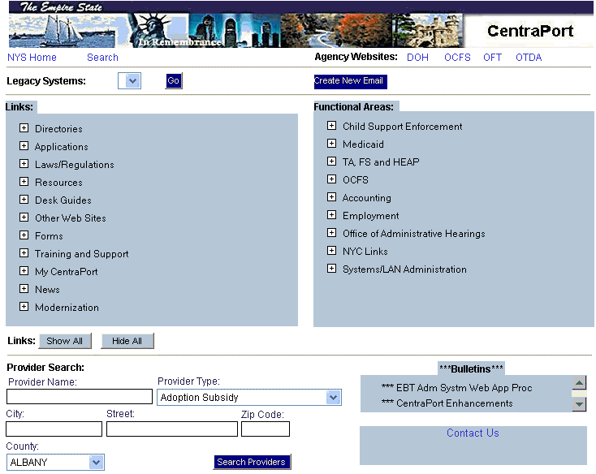
_________________________________________

New York State’s human services agencies (OTDA, OCFS, DOH) and OFT, provide a central point of access to the information and computer systems needed to perform normal agency functions. This central point of access is called CentraPort. CentraPort is a gateway to the Internet and State Intranet—a starting point for users to access frequently used programs or sites. It provides access to a personalized collection of information and computer applications, including locally developed initiatives, on a single summary screen.

CentraPort is available only from the New York State Human Services
(NYSHS) Intranet by using a secure username and password. It is browser-based, which means it looks and functions like a website on the Internet. From CentraPort, the user clicks links (which are shown as icons or underlined text) to access a file or computerized system application.

CentraPort provides numerous data, system, and web page links. They are grouped into the following areas:

- Agency Websites
OTDA, DOH, OFT, and OCFS homepages
- Legacy Systems
Access to CSMS and WMS through Attachmate

Directories
County Profiles, NYS Telephone Directories and access to OTDA statewide and county statistics

Applications
E-HEAP, SOLQ, Web EEDSS, I/EDR, EBT Web Admin, eMedNY, WTWCMS, Automated Application Module (AutoApp), COLD, COGNOS Upfront Access and eReports.
- Laws/Regulations
Book 18, Federal Register, NY Consolidated Laws, NYCRR Title 10 Regulations
- Desk Guides
Access to Food Stamp, HEAP and TA Desk Guides
- Resources
Food Stamp Source Book, WMS Code Cards, HEAP Manual, Kelley Blue Book, WMS Error List, etc.
- Other Websites
Web pages for SSA, NYS Inmate Look-Up, US Zip Codes and Addresses, MapQuest, etc. Additional Internet links are made available to county workers, as needs are identified.
- Forms
OTDA, OCFS and IAF Forms
- Training and Support
OTDA & OCFS Training Opportunities, CentraPort Reference Guide, Training Space, etc.
- News
Governor's Press Releases
- Modernization
Link to Intranet site for Statewide WMS and I/EDR project information.
- My CentraPort
Users can set preferences on their CentraPort main screen and can change their password.

CentraPort also provides resources, based on programmatic, Functional Area. The Functional Areas include Child Support Enforcement, Medicaid, Temporary Assistance, Food Stamps, HEAP, OCFS, Accounting, Employment, Office of Administrative Hearings, NYC Links and Systems/LAN Administration. Within these functional areas, users can access Policy Directives & Transmittals, such as ADMs, INFs, LCMs and WMS Coordinator Letters, as well as other program specific information, including the E-HEAP Workbook Demo and the HEAP Oil Buying-Participating Vendors.

There is a CentraPort Intranet Search tool, allowing users to find documents and resources available on the OTDA Intranet. CentraPort users can retrieve and view federal, State and local agency documents, training and reference materials and statistics. Once the information is viewed and seen as valuable, the user can add the document or web page as a favorite link on CentraPort, so that it can be easily referenced at another time.

The CentraPort Provider Search is an online tool that enables users to search for and retrieve information about state and local programs and community service providers from various New York State agency databases. The Office of Temporary and Disability Assistance (OTDA), as well as other agencies and vendors, maintain these databases. The types of records currently available include:

- A list of Congregate Care Facilities
- The BICS Vendor File
- A list of Electronic Benefit Transfer (EBT), Point of Sale (POS) and Automated Teller Machine (ATM) locations
- A directory of state licensed childcare providers and county-specific provider lists.

Workers can search and locate provider services to meet the needs of their clients. Entering the provider type and location information (city, county or zip code) criteria will initiate a search for providers. The specific provider information available includes name, phone number, address, directions and maps to provider sites, and service descriptions. Districts also have the ability to add local service providers to the Provider Search area. Categories have been identified, based on the BICS Vendor file. See the summary, describing the role of the local CentraPort administrator.

Automated Application Module (AutoApp) allows workers to register an application in WMS by using their PC, instead of a WMS terminal. This browser-based application is accessed through CentraPort and enables users to create, register, perform maintenance, as well as withdraw an application on WMS. AutoApp also allows workers to create a temporary or unregistered application, which stores the partial application until all of the necessary client data is received.

Through AutoApp, the WMS worker can generate additional applications from an existing or closed case (Multiple Apps). This eliminates the need to collect duplicate information and allows a new application to be created for different case types. Clearance reports are available on-line through AutoApp. In addition, Clearance reports and App TAD reports can be requested and printed on demand.

Local CentraPort Administrator Role: Each county may identify an individual as the local CentraPort administrator. This individual may or may not have other administrative responsibilities within the district. The local administrator accesses CentraPort using the same user ID and password as previously assigned, however the properties, now associated with the user ID, grant the authority to function in the administrative role. The local CentraPort administrator’s role affects the local users’ ability to fully benefit from the resources available through CentraPort. Tasks of the administrator include:

- Adding local service providers into the Provider Search area
- Modifying/deleting local provider records located in the Provider Search area
- Adding links onto CentraPort
- Modifying or deleting locally entered links from CentraPort

It is important for a local administrator to be aware of the resource needs of district staff. Maintaining local service providers in the Provider Search area provides a valuable resource for staff as they search for information to assist their clients. Therefore, it is vital that the lists reflect up-to date information on the providers that accept referrals and provide necessary services for the county. Each district independently decides which local providers should be added to Provider Search area. Some counties may choose to add a comprehensive list of community-based organizations within their county, while others may choose to add only agencies that most often provide direct services to their clients.

The local administrator also maintains local web links. Web links, considered pertinent to all staff, are added and maintained by State CentraPort administrators. Local administrators may add links providing information to assist county workers in their job duties including any locally developed applications, such as front door tracking and workflow initiatives. As with Provider Search, each county decides independently which web links they add to CentraPort.

For More Information About CentraPort Contact:

Laura Ziegler

LAURA.ZIEGLER@DFA.STATE.NY.US
473-2578

