Incarcerated Noncustodial Parents
Department of Correctional Services (DOCS) Website Lookup Instructions

How do I verify whether the noncustodial parent is incarcerated?

The New York State Department of Correctional Services (DOCS) maintains a website where individuals can verify if an individual is incarcerated in a State correctional facility, and if they are, where they are incarcerated. The website is www.docs.state.ny.us. By entering this website address, you will get to the DOCS home page which will allow you to do inmate lookups (click on the “Inmate Lookup” tab) and also obtain the mailing addresses for each of the 72 DOCS facilities (click on the “Find a Facility” tab).

How do I obtain information from the DOCS website?

Once at the DOCS home page, you will click on “Inmate Lookup,” and this will bring you to the “Inmate Population Information Search” screen.

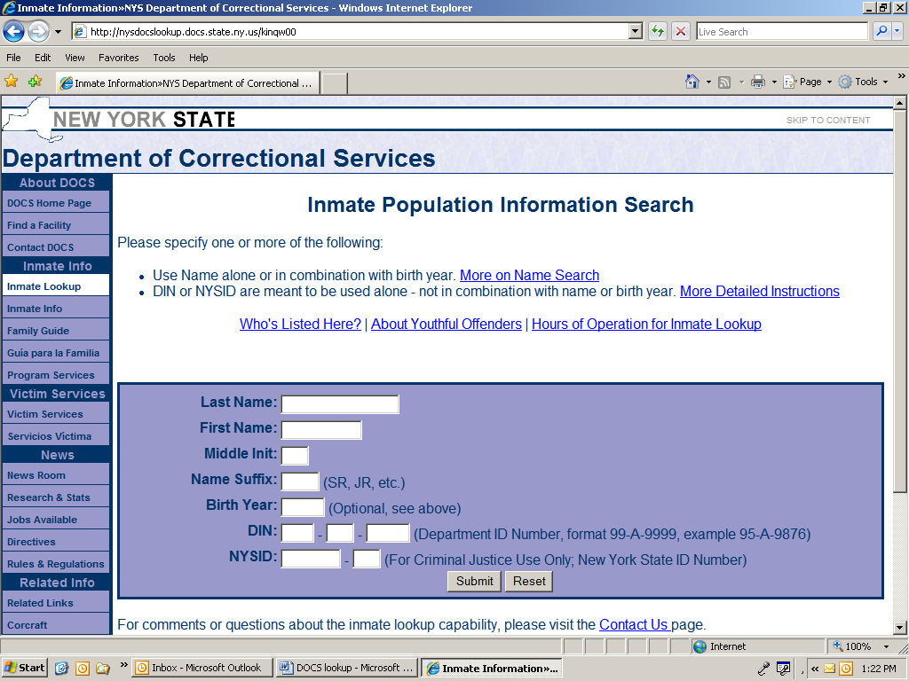

From here you can search for an inmate in two different ways:

- NYSID number: The NYSID-NO is contained on the CSMS IVDJRL screen. Please note that as the data match for the NYSID number is based on a match between the CSMS SSN and the DOCS SSN, there may be a number of cases where the SSNs don’t match, and thus no NYSID-NO will be on CSMS, though the individual is incarcerated. Thus, if someone notifies child support that the noncustodial parent is incarcerated, a name search should be conducted on the DOCS site.

- Name Search: If you search by name on the DOCS site, and there is more than one inmate with that name, the website will display a list of inmates with that name. This list will provide information on the inmate’s birth date, sex, race, and status. This information should help you determine which, if any, of the inmates is the noncustodial parent in the case.

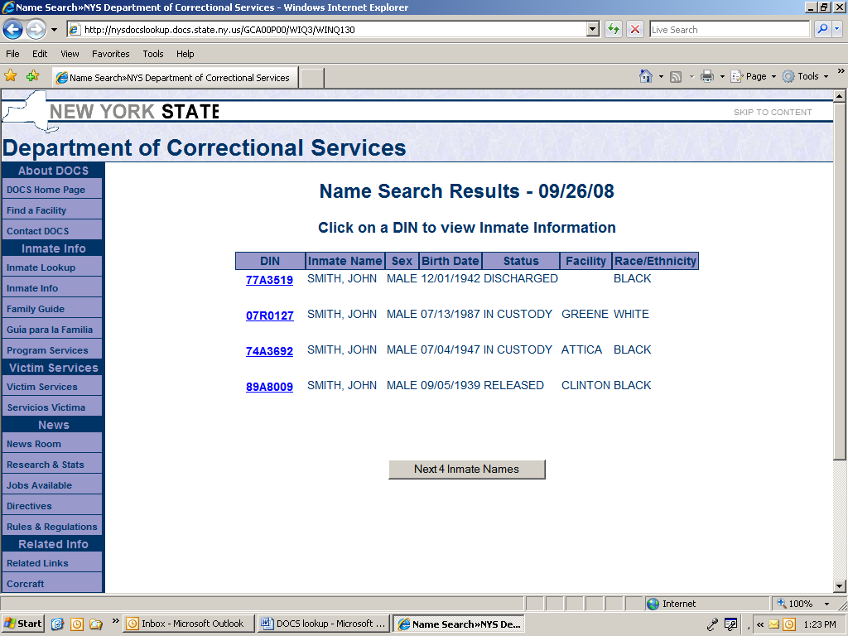

What noncustodial parent information is on the DOCS website?

Once the NYSID or name search results in a hit and you click on the inmate that you are searching for, the “Identifying and Location Information” screen will appear. This screen provides information on where the noncustodial parent is incarcerated and other information on their incarceration.

